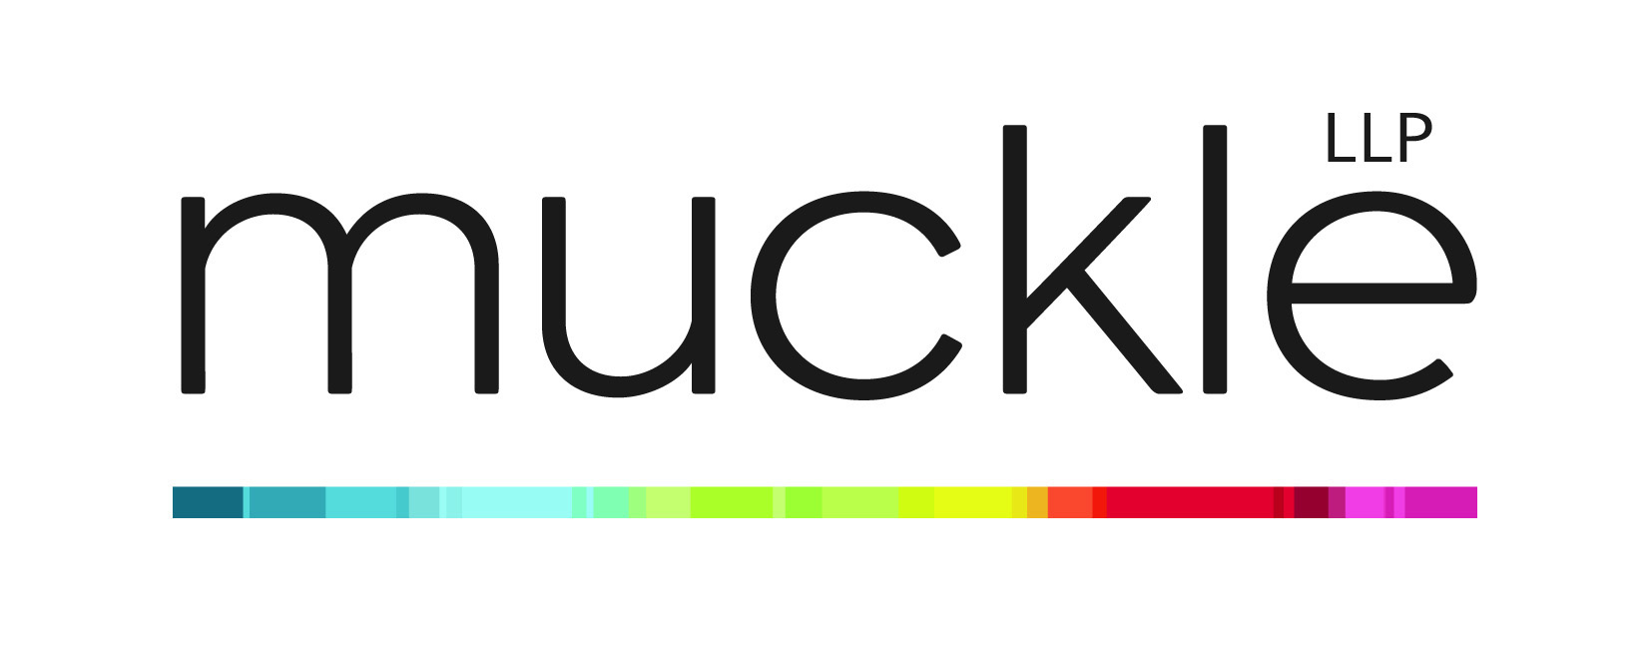
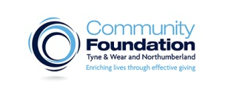
Asset Transfers: Opportunity or Liability?
Property Workshop and Advice Clinic
Wednesday 13th July 2016 10am-4pm
Community Foundation, Philanthropy House, Woodbine Road, Newcastle upon Tyne, NE3 1DD

The Ethical Property Foundation is a UK charity launched in 2004, to support non-profits with high quality property advice free at the point of access, with 3000+ clients to date. In February 2015 the Foundation became a preferred supplier of land and property advice to the Charity Commission.

Charities and community groups are increasingly choosing to take on asset transfers from local authorities as a means of acquiring property. However without proper management, any property is at risk of becoming a liability, with unforeseen costs and unexpected problems putting strain on organisations which are often already overworked.

Property Workshop 10am – 1pm
This training is designed to give a jargon free, accessible introduction and overview of how to make asset transfers a success:
- How taking on an asset can benefit your organisation
- How to engage with local authorities
- Business planning to assess the viability and sustainability of taking on community buildings
- Legal structures and governance issues to consider when considering taking on community buildings
- Identifying ‘hidden’ hazards or responsibilities: what are you ACTUALLY taking on
- Common mistakes and how to deal with them
- Lessons from others

Property Advice Clinic 2-4pm
The half day training session will be followed by a property advice clinic to give you the chance to have a 20 minute session with one of our advisers, on an individual basis. The clinic will have one lawyer and one property adviser. Spaces are limited.

Booking
Please fill in the booking form

