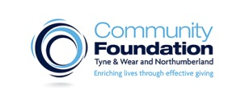

BOOKING FORM
Asset Transfers: Opportunity or Liability?
Property Workshop and Advice Clinic
Wednesday 13th July 2016 10am-4pm
Community Foundation, Philanthropy House, Woodbine Road, Newcastle, NE3 1DD

Organisation:
Attendee name:
2nd Attendee name: (if applicable)
Address:
Post code:

Email Address:

Tel. No.

Number of tickets for Workshop (max two per organisation) :

I would like a 1 to 1 with one of the advisers : YES/NO
Please note 1 to 1 spaces are limited and are on a first come first serve basis

If you want a 1 to 1 please give a short sentence covering the advice you require :

Please return this form BY FRIDAY 1 JULY via e-mail to general@communityfoundation.org.uk or post to
Community Foundation, Philanthropy House, Woodbine road
Newcastle upon Tyne NE3 1DD

