We all know the story of Jack and the Beanstalk. How he planted beans and watched them grow.
You could plant seeds in Tees Valley and help children to read, grow and succeed.
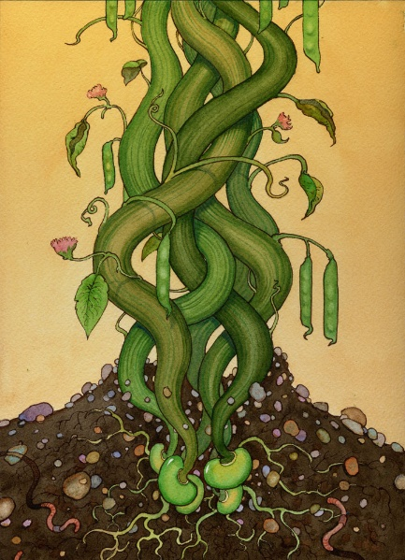
Come and find out how!
Meet us at Strikes Garden Centre,
The Roundabout, Meadowfields
Stokesley, TS9 5HJ
On Thursday 23rd April 2015, 1-4pm
For more information about Beanstalk look at our website: www.beanstalkcharity.org.uk Or call us on 0845 4500 344
In Partnership

