Middlesbrough’s

Question Time

Election Debate
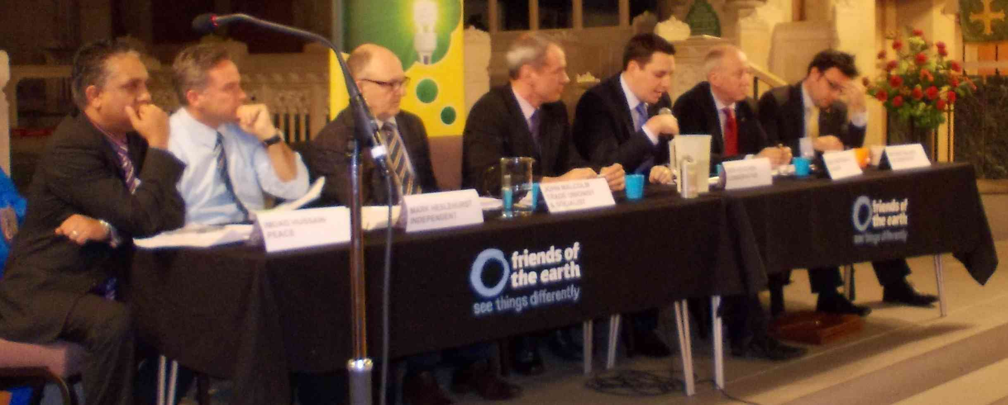

Photo from successful 2012 Middlesbrough Hustings

Tuesday 28th April 6.45 for 7-8.30pm
Linthorpe Road Resource Centre,
54 Borough Road, Middlesbrough, TS1 2JH.

All of the Candidates. You ask the Questions! What is important to you? What are the BIG issues? The NHS, education, economy, environment, housing, defence, jobs, benefits. . .

Only Middlesbrough Voters due to space restrictions, sorry.



