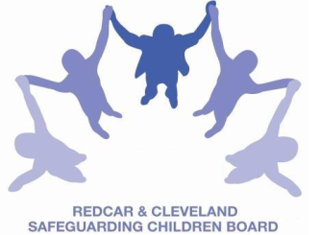
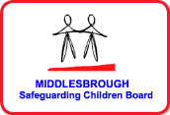

SAFEGUARDING CHILDREN BOARD MULTI-AGENCY TRAINING
APPLICATION FORM

SAFEGUARDING THE UNBORN AND NEW BORN BABY
– FROM CONCEPTION TO 6 WEEKS OLD

This half day course is facilitated by Sue Taylor, Specialist Midwife on behalf of the Safeguarding Children Boards (covering Middlesbrough and Redcar & Cleveland).

Date & Time | MONDAY 4TH JULY 2016 | 9.30am-1.00pm  (Tea/Coffee 9.15am)
Venue | Bridgeway, Allendale Road, Ormesby, Middlesbrough TS7 9LF
PLEASE NOTE:
- In accordance with LSCB Charging Policy this course is free to not for profit agencies in the Middlesbrough & Redcar & Cleveland area
- A non-attendance charge will be incurred if the applicant, having secured a place on the course, does not attend and their manager will be informed of their non-attendance.
- By applying to attend this course you agree to complete an evaluation on the day
and also an impact evaluation approximately 6 months after attending.
Aim | By the end of the session participants will be able to:  - recognise/identify concerns about an Unborn baby  - understand the procedures to follow once concerns about an UBB have been identified and know how to respond
Learning Outcomes | By the end of the course participants will be able to identify the following vulnerable groups of women and respond to them:
  - Drug/alcohol problems  - Learning Disabilities  - Honour Based Violence  - Poor Maternal Mental Health  - Asylum Seekers  - Domestic Violence and | - Be able to identify other professional who need to become involved  - Know where to seek further support and guidance  - To recognise lessons learned from Serious Case Reviews
Applicant’s Details
Name
Job Title/Role
Organisation
Work Address
Telephone
E-mail

Details of applicant’s manager who agrees applicant can attend and that applicant has received child protection awareness training or refresher within last 3 years.
Name:
Telephone

Completed application forms:

Email to: LSCBtraining@redcar-cleveland.gov.uk or
Post to: LSCB Training Administration, Seafield House, Kirkleatham Street, Redcar. TS10 1SP

If you have not heard from us within 7 working days of the course commencing please ring LSCB Training 01642 444336

