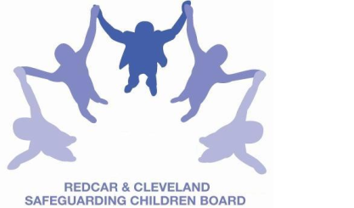
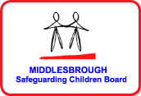
SAFEGUARDING CHILDREN BOARD MULTI-AGENCY TRAINING

APPLICATION FORM
WORKING with NEGLECT – using the Graded Care Profile
SAFEGUARDING CHILDREN & YOUNG PEOPLE
This one day course will be facilitated by Child Centred Practice
*Please note that lunch is not provided at this training day.
Date & Time | TUESDAY 5th JULY 2016 | 9.30am – 4.30pm  (Tea/coffee 9.15am)
Venue | BRIDGEWAY, ALLENDALE ROAD, ORMESBY, MIDDLESBROUGH, TS7 9LF
TARGET AUDIENCE: | Members of the workforce who have particular responsibilities in relation to undertaking section 47 enquiries, including professionals from health, education, police and children’s social care; those who work with complex cases and social work staff responsible for co-ordinating assessments of children in need.
Aim | This one day workshop is intended to support practitioners who work with vulnerable children and their families to use the Graded Care Profile to understand and intervene in cases where neglect is an issue.
Objectives | By the end of the course participants will have explored:  - Understanding Neglect – what is neglect including the legal definition and guidance from DfE. Different types of neglect. Why neglect is difficult to identify and manage effectively.  - Impact of neglect on the child – understanding what the experience of neglect has on the lived life of the child. The physical emotional, social and brain development of the child.  - Emotional Impact of working with neglect on professionals – what happens for professionals who work with neglect and how to support/ challenge practice.  - The Graded Care profile – the development and evidence base. The format and the grading system of the GCP. The language and the intent behind the GCP.  - GCP assessment - Observation of child and parents  - Using the Graded Care profile having guided conversations with families – how to share and explain the Graded Care Profile to promote insight and action.  - Using the GCP Planning effectively with families and agreeing next steps.  By the end of the day, the participants will have a clear idea about what neglect is, what impact it has on child’s health and development and how to use the Graded Care Profile to assess the impact and monitor progress during the intervention.
PLEASE NOTE:
- In accordance with LSCB Charging Policy this course is free to not for profit agencies in the Middlesbrough & Redcar & Cleveland area
- A non-attendance charge will be incurred if the applicant, having secured a place on the course, does not attend and their manager will be informed of their non-attendance.
- By applying to attend this course you agree to complete an evaluation on the day
and also an impact evaluation approximately 6 months after attending.

Applicant’s Details
Name
Job Title/Role
Organisation
Work Address
Telephone
E-mail

Details of applicant’s manager who agrees applicant can attend and that applicant has received child protection awareness training or refresher within last 3 years.
Name:
Telephone
Manager’s
e-mail address

Please return completed application form to:

Email to: LSCBtraining@redcar-cleveland.gov.uk or

Post to: LSCB Training, Seafield House, Kirkleatham Street, Redcar. TS10 1SP or

Apply online at: LSCB Training – Redcar and Cleveland or LSCB Training - Middlesbrough

If you have not heard from us within 7 working days of the course commencing please ring LSCB Training 01642 444336.

