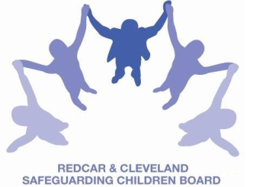
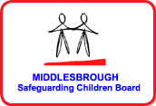

SAFEGUARDING CHILDREN BOARD MULTI-AGENCY TRAINING
APPLICATION FORM
WORKING WITH ‘DISGUISED COMPLIANCE’ –incorporating professional challenge and scenarios involving ‘Toxic Trio’
Facilitated by Ruth Pearson, Independent Trainer
Date & Time | FRIDAY 8th July 2016 |  |  | 09.30am-4.30pm  (Tea/Coffee 9.15am)
Venue | BRIDGEWAY, ALLENDALE ROAD, ORMESBY, MIDDLESBROUGH TS7 9LF
Aim | To facilitate discussion and address concerns about working with families who are partially compliant or deliberately mislead agencies
Objectives | By the end of the course participants will:  - Have more understanding of the issue of disguised and incomplete compliance  - Have explored the concept of ‘Toxic Trio’ (through case scenarios) and its impact on parents/carers ability to care for and protect children & young people  - Be aware of issues from research and national and local Serious Case Reviews  - Develop skills of authoritative and assertive practice and confidence to challenge
PLEASE NOTE:
- In accordance with LCB Charging Policy this course is free to not for profit agencies in the Middlesbrough & Redcar & Cleveland area
- A non-attendance charge of £50 will be incurred if the applicant, having secured a place on the course, does not attend and their manager will be informed of their non-attendance.
- By applying to attend this course you agree to complete an evaluation on the day
and also an impact evaluation approximately 6 months after attending.
Applicant’s Details
Name
Job Title/Role
Organisation
Work Address
Telephone
E-mail

Details of applicant’s manager who agrees applicant can attend and that applicant has received child protection awareness training or refresher within last 3 years.
Name:
Telephone
Manager’s
e-mail address

Completed booking form

Email to: LSCBtraining@redcar-cleveland.gov.uk or
Post to: LSCB Training Administration, West Locality Base, Daisy Lane, Ormesby, Redcar & Cleveland, TS7 9JF.
If you have not heard from us within 7 working days of the course commencing please ring LSCB Admin 01642 444336.

