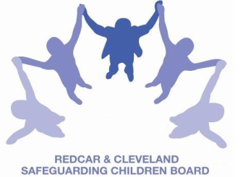
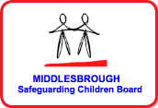

SAFEGUARDING CHILDREN BOARD MULTI -AGENCY TRAINING

APPLICATION FORM
SAFEGUARDING CHILDREN AND YOUNG PEOPLE FROM SEXUAL EXPLOITATION
This one day course will be facilitated by staff from Barnardo’s SECOS Project.
Date & Time |  |  | TUESDAY 12th JULY 2016
Venue |  |  | BRIDGEWAY, ALLENDALE ROAD, ORMESBY. MIDDLESBROUGH TS7 9LF
Aim |  |  | To increase effectiveness in working together to safeguard children and young people from exploitation.
Objectives |  |  | - Increased knowledge about the current local and national context regarding children and young people who are exploited.  - Explore how young people become involved in/at risk of sexual exploitation.  - Identify risk factors and grooming process of children sexually exploited  - Identify the general context of UK and global trafficking of children.  - Knowledge of relevant UK legislation in the area of trafficking and child sexual exploitation.  - Understand multi-agency practical solutions to safeguard sexually exploited & trafficked children and young people.  - Knowledge of Operation Shield and understand the relevant form and how to complete and circulate this.  - Have increased knowledge of relevant LSCB procedures.
PLEASE NOTE:
- In accordance with LSCB Charging Policy this course is free to not for profit agencies in the Middlesbrough & Redcar & Cleveland area
- A non-attendance charge will be incurred if the applicant, having secured a place on the course, does not attend and their manager will be informed of their non-attendance.
- By applying to attend this course you agree to complete an evaluation on the day
and also an impact evaluation approximately 6 months after attending.
Applicant’s Details
Name
Job Title/Role
Organisation
Work Address
Telephone
E-mail

Details of applicant’s manager who agrees applicant can attend and that applicant has received child protection awareness training or refresher within last 3 years.
Name:
Telephone
Manager’s
e-mail address

Completed application form:

- Email to: LSCBtraining@redcar-cleveland.gov.uk
- Apply online at: LSCB Training – Redcar and Cleveland or LSCB Training - Middlesbrough
- Post to: LSCB Training, Seafield House, Kirkleatham Street, Redcar, TS10 1SP.

If you have not heard from us within 7 working days of the course commencing please ring LSCB Training 01642 444336.

