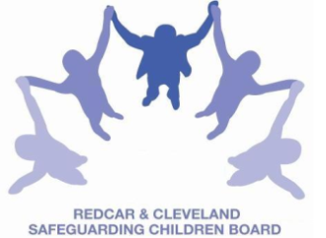
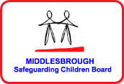

SAFEGUARDING CHILDREN BOARD MULTI-AGENCY TRAINING
APPLICATION FORM
SAFEGUARDING ADOLESCENTS
This full-day course is delivered by members of staff from CAMHS and Middlesbrough BC
Date & Time |  | WEDNESDAY 13th JULY 2016 | 9.30am-4.00pm  (arrival and coffee 9.00am)  PLEASE NOTE LUNCH IS NOT PROVIDED
Venue |  | BRIDGEWAY, ALLENDALE ROAD, ORMESBY, MIDDLESBROUGH  TS7 9LF
Aim |  | To equip practitioners with the skills and knowledge to effectively complete the safeguarding processes with adolescents
Learning outcomes |  | At the end of the workshop delegates will be able to:  - Describe the referral process for safeguarding adolescents  - Outline the issues surrounding vulnerable, exploited, missing and trafficked children in a local context  - Recognise the changing trends in drug use amongst young people and the effects these can have on young people  - Summarise the services offered by Platform Young People’s Substance Misuse Service  - Give examples of how to deliver Sexual Relation Education appropriately  - Outline the self-harm and mental health issues which may affect young people  - Summarise the PREVENT agenda for extremism and radicalisation of young people, and how this is part of the Local Authority’s statutory obligation.  - Explain the use of technology safety and sexting facing young people
PLEASE NOTE:
In accordance with SCB Charging Policy:
- This course is free to not for profit agencies in the Middlesbrough & Redcar & Cleveland area
- A non-attendance charge will be incurred if the applicant, having secured a place on the course, does not attend and their manager will be informed of their non-attendance.
Applicant’s Details
Name
Job Title/Role
Organisation
Work Address
Telephone
E-mail

Details of applicant’s manager who agrees applicant can attend and that applicant has received child protection awareness training or refresher within last 3 years.
Name
Telephone
Email address

Completed application form:

- Email to: LSCBtraining@redcar-cleveland.gov.uk
- Apply online at: LSCB Training – Redcar and Cleveland or LSCB Training - Middlesbrough
- Post to: LSCB Training, Seafield House, Kirkleatham Street, Redcar, TS10 1SP.

If you have not heard from us within 7 working days of the course commencing please ring LSCB Training 01642 444336.

