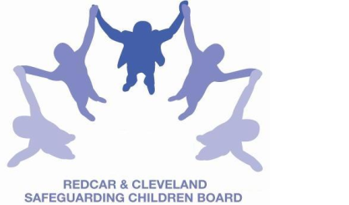
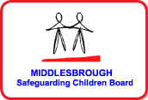

LOCAL SAFEGUARDING CHILDREN BOARD MULTI-AGENCY TRAINING
APPLICATION FORM

RAISING AWARENESS ABOUT
FEMALE GENITAL MUTILATION, FORCED MARRIAGE AND HONOUR BASED VIOLENCE
This half-day course is facilitated by Noreen Riaz, HALO Project, on behalf of the Local Safeguarding Children Boards (covering Middlesbrough and Redcar & Cleveland).
Date & Time | TUESDAY 14TH JUNE 2016
Venue | BRIDGEWAY, ALLENDALE ROAD, ORMESBY,  MIDDLESBROUGH TS7 9LF.
Aim | To ensure delegates have a good understanding of the concepts of forced marriage and honour based violence and to enable them to react appropriately and effectively if presented with a victim or potential victim of forced marriage or honour based violence.  and  To ensure delegates have an understanding of the background, signs, symptoms and health implications of female genital mutilation and to know how to make a referral when you identify female genital mutilation or have concerns female genital mutilation may be practiced.
Objectives | Participants will:  - Be able to define FM and HBV  - Distinguish between a forced and an arranged marriage  - Understand the reasons behind HBV and what abuse it involves  - Be able to identify the warning signs of a potential victim  - Reinforce the importance of the one chance rule  - Understand how to respond to a disclosure of a FM or HBV in order to protect the victims safety  - Be aware of the do’s and don’ts when professionals are faced with potential victims  - Signpost victims to the right agencies and know what services are offered locally and nationally  - Understand your statutory duties in relation to FM & HBV  - Provide essential background information about the practice of FGM  - To raise awareness of the negative health and social consequences of FGM  - Be able to identify the warning signs of a potential victim  - To ensure victims are signposted to the relevant agencies by following good practice guidelines.  - A basic understanding of legislation and the roles and responsibilities of professionals in respect of FGM
Cost: | Free to not for profit agencies in the Middlesbrough & Redcar & Cleveland area.
PLEASE NOTE:
- By applying to attend this course you agree to complete an evaluation on the day and also an impact evaluation approximately 6 months after attending.
- In accordance with LSCB Charging Policy, a non-attendance charge will be incurred if the applicant, having secured a place on the course, does not attend and their manager will be informed of their non-attendance.
Applicant’s Details
Name
Job Title/Role
Organisation
Work Address
Telephone
E-mail

Details of applicant’s manager who agrees applicant can attend and that applicant has received child protection awareness training or refresher within last 3 years.
Name
Telephone
Manager’s e-mail address

Completed application form:

- Email to: LSCBtraining@redcar-cleveland.gov.uk
- Apply online at: LSCB Training – Redcar and Cleveland or LSCB Training - Middlesbrough
- Post to: LSCB Training, Seafield House, Kirkleatham Street, Redcar, TS10 1SP.

If you have not heard from us within 7 working days of the course commencing please ring LSCB Training 01642 444336.

