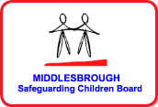
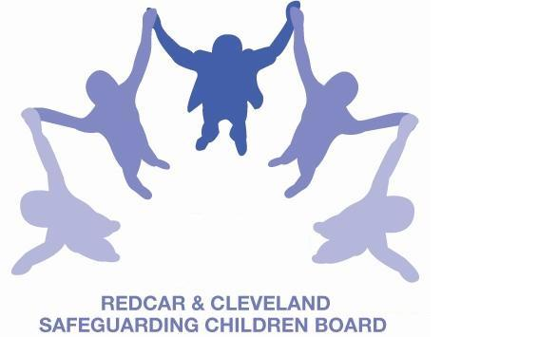

LOCAL SAFEGUARDING CHILDREN BOARD
MULTI-AGENCY TRAINING APPLICATION Form

Multi-Agency Safeguarding Children Training
SAFEGUARDING UPDate 2016/17!

This is an annual update for staff who have already completed safeguarding children core training and who work predominantly with children, young people and/or their parents/carers. This may include teachers, children’s social care staff, health visitors, probation staff, midwives, school nurses, sexual health staff, youth workers, paediatricians, those working in the early years sector, GPs, residential staff, sports club welfare officers, those working with adults in, for example, learning disability, mental health, alcohol and drug misuse services, those working in community play schemes and LSCB members.

9.30am-12.30pm | MONDAY 25th APRIL 2016 | Coffee from 9.15am
PLEASE NOTE:
- By applying to attend this course you agree to complete an evaluation on the day and also an impact evaluation approximately 6 months after attending.
- In accordance with LSCB Charging Policy, a non-attendance charge will be incurred if the applicant, having secured a place on the course, does not attend and their manager will be informed of their non-attendance.
Cost: | Free to not for profit agencies in the Middlesbrough & Redcar & Cleveland area.
Objectives  By the end of the training you will: | - Have raised awareness of new and changing information/guidance and how this can support effective safeguarding practice.  - Have an increased understanding of learning from local and national Serious Case Reviews and implications for practice.  - Have the opportunity to revisit aspects of core competency in multiagency groups reinforcing effective interagency working.  - Have the opportunity to share good practice and gain a greater understanding of the role of partner agencies in the safeguarding process.
Venue: | BRIDGEWAY PROJECT - ALLENDALE ROAD, ORMESBY, MIDDLESBROUGH TS7 9LF
Contact Details
Name:
Job Title / Role:
Your Organisation
Work Address:
Telephone Number
E-mail:

Managers details
attendance on courses will not be approved without the information below
Name:
Telephone Number
Agrees you can attend | Yes No (please tick)

Please return completed booking form to:

Email to: LSCBtraining@redcar-cleveland.gov.uk or

Post to: LSCB Training, Seafield House, Kirkleatham Street, Redcar. TS10 1SP or

Apply online at: LSCB Training – Redcar and Cleveland or LSCB Training - Middlesbrough

If you have not heard from us within 7 working days of the course commencing please ring LSCB Training 01642 444336.

