***Activity Group for May***

***10a.m.-1p.m.***

***May 1st. 10 a.m.-12p.m. C. A. B. .***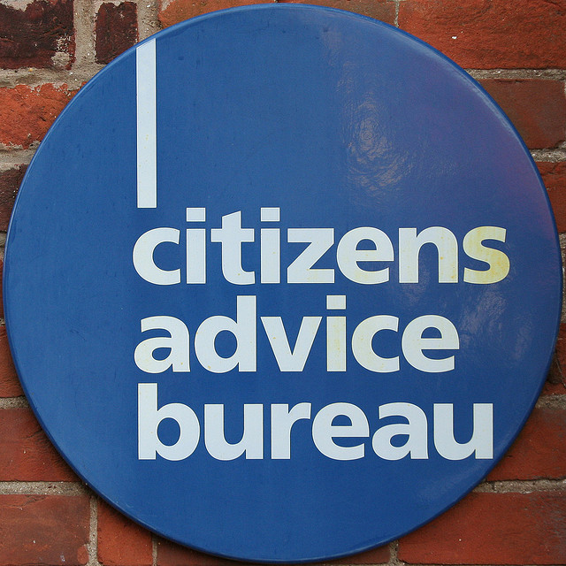

***May1st 12p.m. to 1p.m. Jake and Graham ***

***May8th10a.m. to 12p.m. Ganges with David Merigold ***

***May 8th 12p.m. to 1p.m. Percussion -Colin ***

***May15th 10a.m. to 12p.m. Sailing Theory with John Tate***

***May 15th 12p.m. to 1 p.m. Brenda Arabian Dancing.***

***May 22nd 10a.m. to 12p.m. Brotton with Michael Roe***

***May 22nd 12p.m. to 1.p.m. New Dance Routine ***

***May 29th. 10a.m.-1p.m. Bowling at Bowling Club ***

***Friday Friends Supported by Redcar & Cleveland Borough Council with funding through the Community Health Fund, which RCVDA is delivering on behalf of Redcar & Cleveland Borough Council.***

***Friday Friends*** *Supported by Redcar & Cleveland Borough Council with funding through the Community Health Fund, which RCVDA is delivering on behalf of Redcar & Cleveland Borough Council.*

***Arts and Crafts for May***

***1.30p.m.to 4p.m.***

***May 1st . p.m. Bird in a Cage. ***

***May 8th p.m. Still Life Painting. (please bring object)***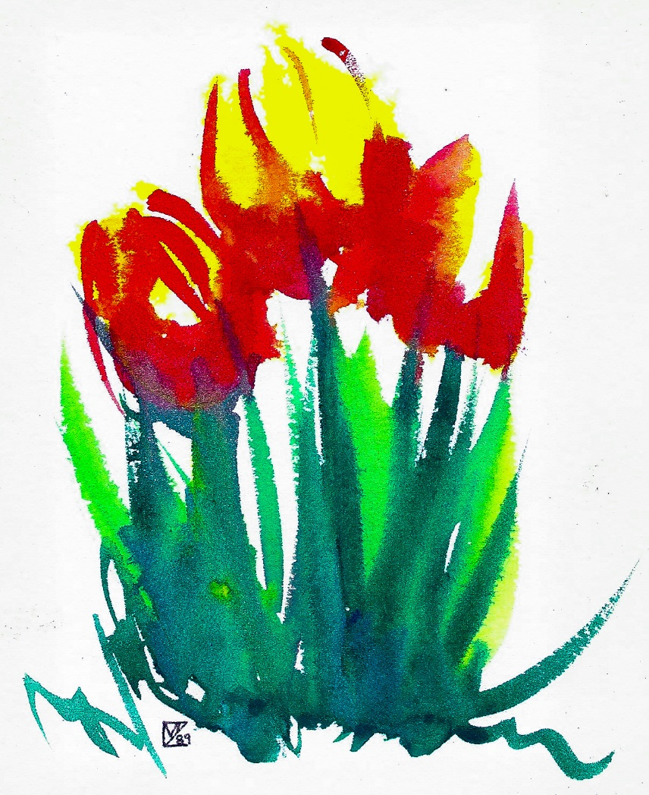

***May 15thp.m. Felt Animal Brooches.***

***May 22nd.p.m. Tea Bag Folding ***

***May 29thp.m. An Abstract Design ***

***Friday Friends Supported by Redcar & Cleveland Borough Council with funding through the Community Health Fund, which RCVDA is delivering on behalf of Redcar & Cleveland Borough Council.***

## Who we are

We are an innovative new small charity, aiming at forming a friendship group in Saltburn. Our aim is to provide a creative environment where friendships can develop and be sustained. Amongst our company are an enthusiastic and professional functional skills teacher, two volunteers, who also volunteer as mental health workers and bring us their experience, a teacher with psychiatric training and experience, an ex-businessman, a highly qualified care worker, a talented artist and three members with extensive committee experience and previous accountancy background. Many of us have had personal experience of mental health issues.

Our planned sessions are designed to include everyone and we hope you will enjoy them. .

Membership is open to anyone, over 18 years of age, without regard to gender, race, nationality, disability, sexual preference, religion or belief. We all are, individually, in possession of a DBS and some have safeguarding certificates.

* Friday Friends, promoting friendship.
* Not for profit and run by volunteers
* Contact Us

**Friday Friends**

Tel No 07948114180 [E-mail-friday.friends8@gmail.com](mailto:E-mail-friday.friends8@gmail.com)

Website fridayfriends.org

Fridays at: Emmanuel Church Hall,

Macnay Street

Saltburn , TS12 1LE

Friday Friends Supported by Redcar & Cleveland Borough Council with funding through the Community Health Fund, which RCVDA is delivering on behalf of Redcar & Cleveland Borough Council.

**Friday Friends**

**Emmanuel Church Hall**

**Saltburn**

**Fridays:**

**Activities Group 10.00a.m. to 1 p.m.**

**Arts and Crafts 1.30 p.m. to 4.00p.m.**

**£2-50 per session**

**£4-00 all day**

**1st session free.**

**Tel No.07948114180**

**e-mail-** [**friday.friends8@gmail.com**](mailto:friday.friends8@gmail.com)

**NOT FOR PROFIT AND RUN BY VOLUNTEERS**

**Friday Friends Supported by Redcar & Cleveland Borough Council with funding through the Community Health Fund, which RCVDA is delivering on behalf of Redcar & Cleveland Borough Council.**