

**An invitation to our Open Day on**

**Saturday 21st November 2015**

**10am - 4pm**

**17 Queen Street, Redcar**

**Pop in and see what it’s all about …**

**A project of Footprints in the Community**

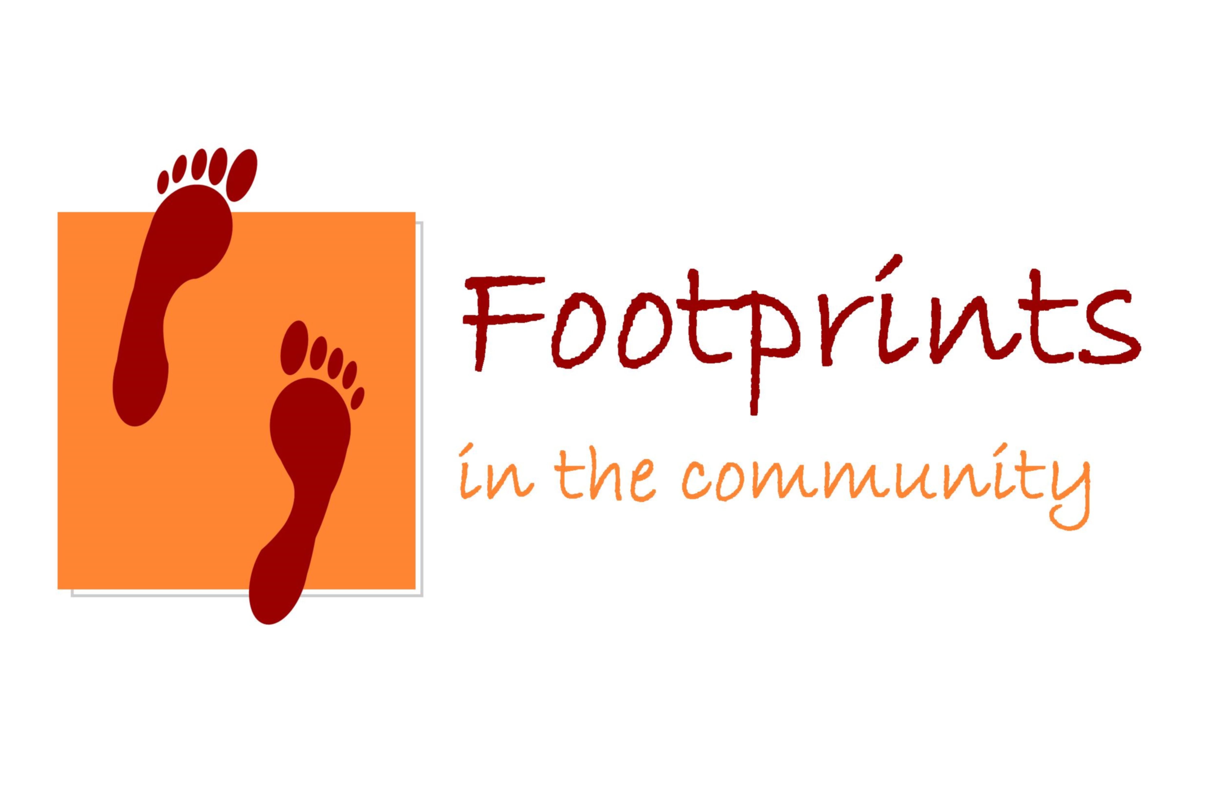

www.footprintsinthecommunity.co.uk