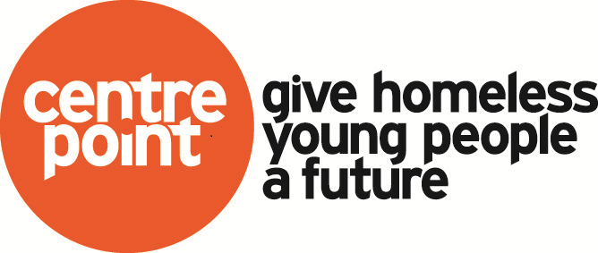
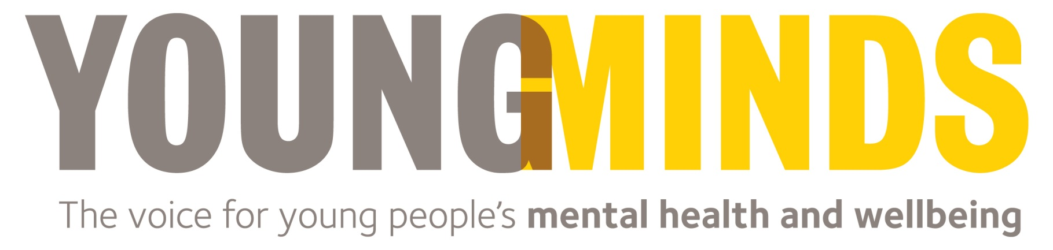
Mental Health Matters
This one-day multi-disciplinary course will enable participants to consider how, through their role; they can promote the mental health and wellbeing of young people, identify early mental health problems and work together with others to improve access to services and support. Participants will explore models of resilience and the ways in which resilience can be developed and strengthened, in the young people that they are working with and in themselves. The course will be interactive and will include a combination of discussion and group work.

What we will cover:
- What we mean by mental health, mental health problems, disorders, illness and behaviours
- What we know are the most common issues and illnesses that young people face
- Adolescent development
- What we can do to support young people experiencing, or at risk of, mental health problems
- Signs and symptoms that young people might be experiencing mental illness
- What young people tell us makes a difference
- An understanding of why young people might self harm and to explore ways in which you can respond positively in order to help
- To give participants some knowledge as well as practical tools which you can use to assess risk and promote resilience
- Finding resilience in ourselves, our workplaces and networks
- Connecting young people to resources that enable them to become more resilient
- Implementing resilient practice
- Signposting

