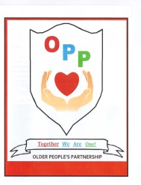
Redcar and Cleveland
Older People`s Partnership

Springtime Afternoon Entertainment
Wednesday 3rd June 2015

With

Ron Spence

Songs from 40`s to the 80`s

Information Stands, Raffle and Refreshments
at
Loftus Town Hall from 1.30 – 3.30

Free bus from Redcar & Marske
To book call Colin on 01642 453868

This event will be preceded by the
Redcar & Cleveland Older People`s Partnership AGM

