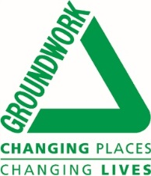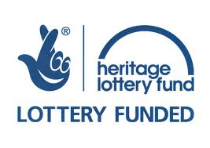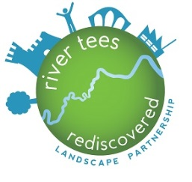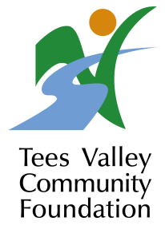

River Tees Rediscovered Landscape Partnership and Tees Valley Community Foundation
****Launch of new fund to support activities connected with the River Tees****
The River Tees Rediscovered Landscape Partnership scheme covers an area of 147km2 within the Tees Lowlands, focusing on the river corridor from the coast upstream of Piercebridge. Supported by over twenty partner organisations and the Heritage Lottery Fund (HLF) over a five year delivery period, the Partnership aims to reconnect communities, organisations and visitors to the river. Further information regarding the River Tees Rediscovered project can be found at www.riverteesrediscovered.org
A new and exciting initiative has been launched by River Tees Rediscovered in conjunction with the Tees Valley Community Foundation, which will enable local groups to apply for funding to support project delivery over a three year period.
Tees Valley Community Foundation will contribute £20,000 per annum to support 20 groups to deliver 20 projects on and around the River Tees each year from 2015 to2018.
This is your opportunity to be involved in creating a positive project for your area which will impact beneficially on your community. It is open to applicants within the following areas: Hartlepool; Redcar and Cleveland; Middlesbrough; Stockton on Tees and Darlington
Grants of £1,000 are available to support groups that celebrate the River Tees through projects involving:
- Heritage
- Environmental activity
- Community Engagement
- Volunteering
- Arts/Culture
- Music
- Sport
- Dance

Speaking about the fantastic grant opportunities, Hugh McGouran, Chief Executive of Tees Valley Community Foundation, said: “TVCF are delighted to help support local groups in the celebration of our majestic River Tees and we look forward to receiving applications for exciting projects that help engage our local communities in activities inspired by the River”.
Doug Nicholson, Chair of the River Tees Rediscovered Landscape Partnership told us: "We are delighted with the generous support and enthusiasm from the Foundation. It's particularly encouraging that they also see the potential for the scheme to benefit the wider community, and to improve perceptions of the lower Tees Valley nationally.”

For more information and to apply online visit: www.teesvalleyfoundation.org.

About the Heritage Lottery Fund
From the archaeology under our feet to the historic parks and buildings we love, from precious memories and collections to rare wildlife, we use National Lottery players' money to help people across the UK explore, enjoy and protect the heritage they care about. www.hlf.org.uk

About Groundwork NE & Cumbria

Groundwork NE & Cumbria helps people and organisations make changes in order to create better neighbourhoods, to build skills and job prospects, and to live and work in a greener way. We know that the important issues are all connected – so our work can’t easily be placed in boxes marked 'environmental issues’, 'regeneration', 'employment' or 'health'. We create projects and services that benefit both people and the wider environment.

We work towards a vision – of a society of sustainable communities, which are vibrant, healthy and safe, which respect the local and global environment and where individuals and enterprise prosper.

Creating those sustainable communities means developing initiatives that cut across economic, environmental and social issues. To achieve our vision we work together with passionate individuals, proactive public services and innovative parts of the private sector to deliver an incredibly diverse range of projects.

We are proud of being a local delivery organisation. Our local programmes and services are tailored to the needs of partners and communities. When all that local activity is added together, it becomes a major regional force for change.

For further information, images and interviews please contact:
Lucy Chapman, River Tees Rediscovered Delivery Officer.
lucy.chapman@groundwork.org.uk Tel: 01642 616144
Facebook / riverteesrediscovered
Twitter @rtrlp

