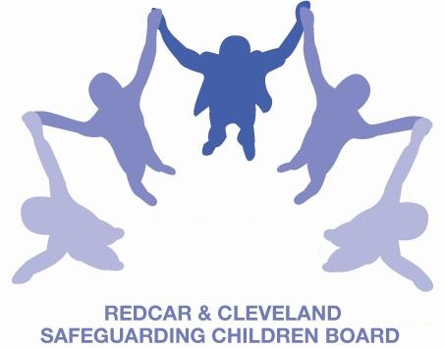
RCSCB E- MAIL BULLETIN – OCTOBER 2015

Welcome to the October edition of RCSCB E-mail Bulletin;

If you have any comments or feedback on this bulletin or any items you would like to submit for future editions. Please email me at: Roslyn.pluck@redcar-cleveland.gov.uk Please check our Redcar and Cleveland LSCB website for regular updates and minutes from Board meetings. www.redcar-cleveland.gov.uk/safeguarding

LSCB TRAINING:

DAY | DATE | TIME | VENUE | COURSE TITLE | TRAINER | COMMENTS
Nov-15
Friday | 27-Nov-15 | 09.30 to 4.30 | Bridgeway | Disguised Compliance | Ruth Pearson, Independent Trainer | Further dates to be arranged. Places are limited but applications will be held if unsuccessful for this date.
Dec-15
Thursday | 03-Dec-15 | 09.30 to 4.30 | Bridgeway | Domestic Abuse - general overview | Mary Griksaitis, Child Protection Officer, Middlesbrough Education, Kerry Daniels, Domestic Violence Reduction Worker, Middlesbrough and Janet Husband, Early Help Lead, Redcar and Cleveland

Further training dates to be confirmed and these will be included in future versions of the brochure. Look out for updates at:
LSCB Training – Redcar and Cleveland or for more information on training please contact Denise Skillcorn LSCB Training Support and Development Officer: Phone: 01642 444336 (Internal extension: 4336) denise.skillcorn@redcar-cleveland.gov.uk

E-Learning:
For free e-learning for parents’ on Child Sexual Exploitation visit: www.safeguardingchildrenea.co.uk/keep-them-safe

The Home Office has launched a free online training package dealing with female genital mutilation (FGM), developed with Virtual College. The aim of the training is to provide an overview of FGM and professionals’ responsibilities in FGM cases. Follow the attached link and enter a few details including email address and where you work. Home Office FGM e-learning

An online training course regarding PREVENT may be accessed at: http://course.ncalt.com/Channel_General_Awareness. This will take approximately 25 minutes to complete and the certificate, printed after completion, will specify online Channel Awareness Training with the College of Policing.
NATIONAL NEWS
Neglect remains the most common form of child abuse across the UK. Numbers of recorded cruelty and neglect offences in England and Northern Ireland are now the highest they have been for a decade. Read more at nspcc.org.uk/howsafe

Hurting inside: NSPCC report on the learning from the NSPCC helpline and ChildLine on neglect.
Summary: Analysis of contacts about child neglect to the NSPCC adult helpline. Shares what children tell ChildLine about their experiences of neglect. Key findings include: neglect is the top reason why people contact the helpline; helpline statistics show that adults are more likely to report concerns about younger children in relation to neglect; younger children are often not aware they are being neglected and rarely seek help. Illustrates how a call to the helpline can make a difference to a child's life.
Publication details: London: NSPCC, 2015
ISBN:
Shelf mark:
Authors: Michelle Turnbull
Corporate authors:

The NSPCC's Information service has published a factsheet explaining how the National Referral Mechanism (NRM) works to identify and support victims of human trafficking.
Source: NSPCC Website 18 September 2015

SERIOUS CASE REVIEWS

Please click on the following link to access a list of newly published and historical reports that have been identified and added to the repository during the preceding month:
Case reviews added – September 2015

See the NSPCC webpages for information about the repository, research on case reviews and our full list of at a glance briefings. Our most recent briefing provides a summary of risk factors and learning for improved practice for the health sector (paediatrics and accident & emergency):

If you’d like to see a list of reports from our LSCB:

Open the NSPCC library online: http://www.nspcc.org.uk/preventing-abuse/research-and-resources/search-library/
Under Advanced search
Select Publisher from the Search in drop-down menu
Enter Redcar and Cleveland in the Search terms box
Select Case reviews from the Media type drop-down menu:
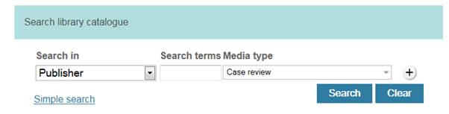

The NSPCC is able to publish case review reports where the commissioning LSCB is not named, provided that the National Panel of Independent Experts has agreed that this is appropriate for that case, please contact them for further information: NSPCC information service 020 7650 6960.

The RCSCB E-mail bulletin is sent to all Board Members and Sub Group Chairs. While members are welcome to forward this to colleagues (where appropriate), we would ask that secondary recipients raise any queries about the bulletin, or its attachments and hyperlinks, with the RCSCB Business unit in the first instance.

