
Reactivate Redcar & Cleveland is a project funded by Sport England/Big Lottery
designed to get residents (aged 14 upwards) in South Bank, Grangetown, Coatham, Newcomen, Kirkleatham & Loftus more active

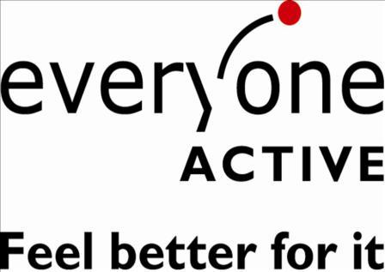

OUTDOOR @ REACTIVATE R&C
All sessions are free for under 18s* and £1 everyone else

ACTIVITY MEETING PLACE DAY TIME START DATE
Couch2parkrun** Locke Park, Redcar Tuesday 10am w/c 22nd Feb
Couch 2 5k** Leisure Centre, Redcar Thursday 12pm w/c 7th March
Leisure Centre, Loftus Friday*** 11am w/c 22nd Feb
Mums on the Run Leisure Centre, Eston Wednesday .30am w/c 29th Feb
Tuned In!, Redcar Thursday 9.30am w/c 7th March
Nordic Walking** Flatts Lane Tuesday 12pm w/c 7th March
Cricket Club, Loftus Friday*** 1pm w/c 7th March
Tuned In!, Redcar Saturday 9am ` w/c 7th March
For more info contact; taraoxley@everyoneactive.com 01642 447721
*under 16s must take part with an adult
**These sessions are a 10 week beginner program ***Excluding Good Friday
SWIM @ REACTIVATE R&C
ESTON LEISURE CENTRE
All Sessions only £1.00 Each
SESSIONS TIME DATES
Ladies Only Learn 2 Swim* 9-9.45 Weds Feb 24th - March 23rd
Ladies Only Session 9-10.00 Weds Feb 24th – March 23rd
Mixed Learn 2 Swim* 12-12.45 Weds Feb 24th - April 27th
Mixed Swim Clinic 1.30-2.15 Mon Feb 22nd – April 27th
Swim 4 Fitness 2.30-3.30 Mon Feb 22nd – April 27th
Parent & U14 Intro to Water 4-5.00 Thursday 25th – April 28th

*LIMITED SPACES ON THE LEARN 2 SWIM SESSIONS BOOKING ADVISED
For more information contact jennymiles@everyoneactive.com 01642 447721

LOFTUS LEISURE CENTRE
All Sessions only £1.00 Each
SESSIONS TIME DATES
Aqua Fit 7.30-8.15pm Mon Feb 22nd – April 25th
Ladies Only Learn 2 swim* 8.15 – 9.00pm Mon Feb 22nd – April 25th
Mixed Learn 2 Swim* 9.00 – 9.45am Tues Feb 23rd – April 26th
Swim Clinic 10.15 – 11.00am Tues Feb 23rd – April 26th
Adult & Child Water Confidence 9.00 – 10.00am Thurs Feb 25th – April 28th

*LIMITED SPACES ON THE LEARN 2 SWIM SESSIONS BOOKING ADVISED
For more information contact jennymiles@everyoneactive.com 01642 447721

REDCAR LEISURE & COMMUNITY HEART
All Sessions only £1.00 Each
SESSIONS TIME DATES
Mixed Swim Clinic 12.00 – 12.45 Thurs Feb 25th – April 28th
Mixed Learn 2 Swim* 1.00 – 1.45 Thurs Feb 25th – April 28th
Swim 4 Fitness 2.30 – 3.30 Thurs Feb 25th – April 28th
FlowRider** 11.30 – 1.00 Friday Feb 26th – April 29th
FlowRider** 1.00-2.30 Friday Feb 26th – April 29th

Limited spaces on the Learn 2 Swim & FlowRider Sessions
**New FlowRider sessions every 4 weeks - Term Time Only
For more information contact jennymiles@everyoneactive.com 01642 447721

Indoor@Reactivate

Eston Leisure Centre
A fun, relaxed, social game to kick-start your active life

Activity Location Time Dates
No Strings Badminton Eston Leisure Centre 10.00am – 11.00pm Tuesday: March 1st – March 26th
No Strings Badminton Eston Leisure Centre 2.00pm – 3.00pm Thursday March 3rd – March 28th

Only £1 per Session
For more information please call 01642 44 77 21 or email philipseymour@everyoneactive.com

Facebook: Reactivate Redcar Twitter: Reactiv8_redcar

