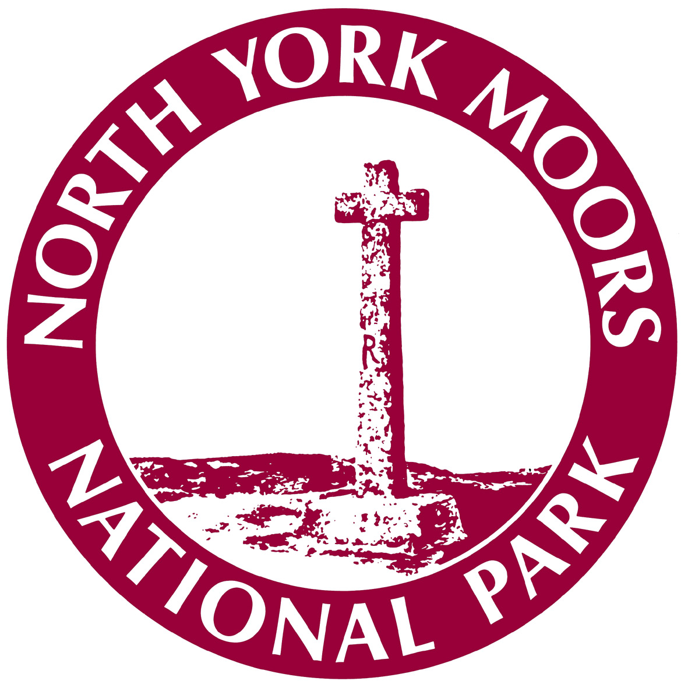 | Targeted Transport 2016/17  Application for Visit

1 Contact Details
User Group
Contact Name
Contact Address  Post Code | Phone (landline)  Phone (mobile)  Email
Name of Person accompanying the Group (if different from above)

Contact Address  Post Code | Phone (landline)  Phone (mobile)  Email

2 Date(s) & Visit Requirements
Date(s) (please give alternatives if possible) , pick-up and drop-off times

Date:

Pick up time:

Drop off time;

Minibus / Coach Pick-up Point & Address  Post Code | Destination(s) of Visit
Number of Visitors (minimum 10 maximum 16 per mini-bus, minus 2 seats for wheelchair space)

Are there any special requirements for the Visit which the Mini-bus/ Coach provider or Attraction(s) need to be aware? Yes / No (if Yes please provide details below)

3 BME Approval (BME groups only)
Authorising officer signature

Date

Email address

Phone (mobile preferred)

Is this a repeat visit by this group? (if Yes please state date/destination of previous visit)

Please email this form to e.mckenzie@northyorkmoors.org.uk or post to Emma McKenzie, North York Moors National Park Authority, The Old Vicarage, Bondgate, Helmsley, York. YO62 5BP.

A minimum of 3 weeks’ notice from receipt of Visit Application is normally required to allow for vehicle booking and administration. An email confirming acceptance of the booking, the date and timings will be forwarded to the group contact.
For BME a Visit Confirmation will be forwarded by Email to the Authorising officer as soon as booking details are finalised.

The details you provide will automatically be added onto our Targeted Transport mailing list, should you wish for your details not to be used in this way please contact us.
The information you provide will be held under the Data Protection Act 1998 and will not be used for any other purpose than for information regarding the Targeted Transport Scheme.

