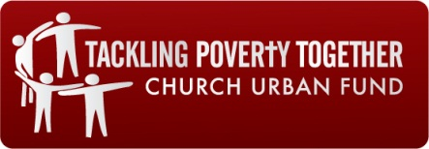

TOGETHER MIDDLESBROUGH AND CLEVELAND
A Joint Venture between the Diocese of York and the Church Urban Fund

DEVELOPMENT WORKER (Redcar and Cleveland) 20 hours per week
Do you believe the church has a vital role to play in tackling poverty?
Do you have a vision for a Christian response to tackling poverty and disadvantage?
Are you passionate about spiritual and social transformation?

The purpose of Together Middlesbrough & Cleveland is to enhance the capacity of the churches’ mission and neighbourliness in the communities of South Teesside, engaging the churches in addressing poverty.

Our vision is to
- Enable churches to make a greater contribution to the social and spiritual transformation of communities
- Support churches and faith-based organisations’ response to poverty and marginalisation, and to the current economic and employment situation – through direct funding, development work and infrastructure support.
- Enable churches to influence and shape social and economic policy

We need someone with passion and imagination and the ability to communicate this vision to create a movement of churches tackling poverty together.

You must have excellent communication skills, an ability to develop relationships with a wide range of people, experience of working with the local church and an understanding of the issues and impact of poverty and deprivation.

For further details, please download the job description and the application form. Applications to be sent to Mrs Julie Elphee, Bishop of Whitby’s Office, 21 Thornton Road, Stainton, Middlesbrough TS8 9DS, email: julie.elphee@yorkdiocese.org
Successful candidates will be required to undertake a DBS check.

Salary: £16,354 (20/35 pro-rata of £28,620)
Contract: Permanent
Closing date for applications: Noon on Monday 7 December 2015
Date of interview: Wednesday 16 December 2015 (am)
Place of interview: Redcar and Cleveland (venue to be confirmed)

