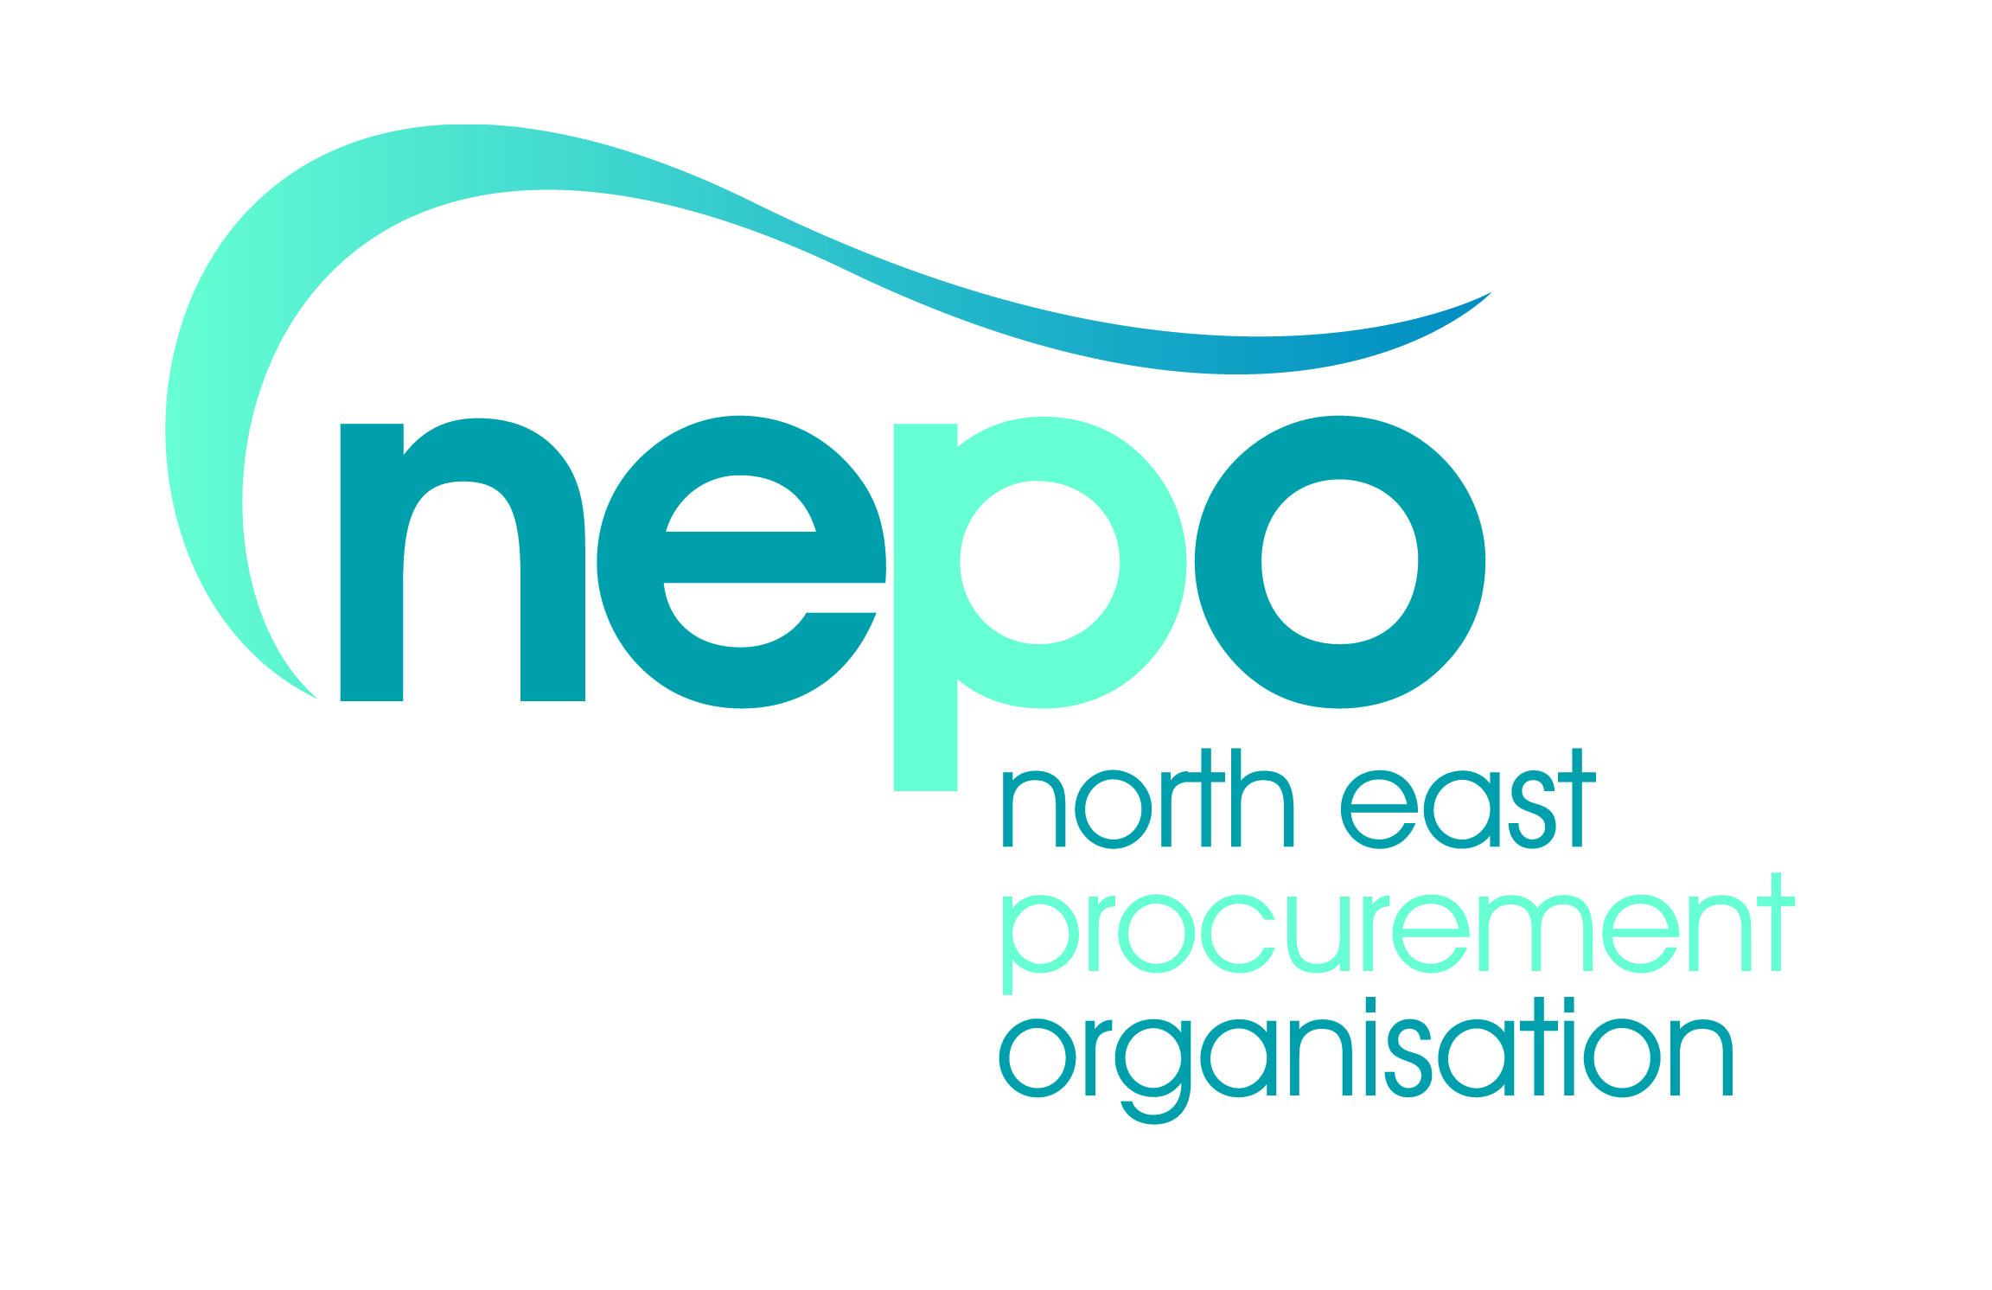
Voluntary & Community Sector Engagement Event
Social Value in Procurement

Monday 30th November 2015, 09.30am – 12.45pm
Committee Room 2, Ground Floor, County Hall, Durham, DH1 5UL

Speakers
Ross Smith | North East Chamber of Commerce (Chair of NEPO Stakeholder Engagement Group)
Nicola Shelley | NEPO – Senior Procurement and Services Manager
Denise Pearson | Chair of NEPO Social Value Delivery Group

9.30 – 10.00 Arrival, refreshments and networking

10.00 – 10.15 Introduction and NEPO Overview – Ross Smith
Introduction to NEPO and the Stakeholder Engagement Group

10.15 – 10.25 Objectives of the day – Nicola Shelley

10.25 – 10.55 Guest speakers
2 current NEPO suppliers providing examples of how they have successfully worked with the VCS.

10.55 – 11.15 NEPO Social Value Overview and Policy – Denise Pearson
Overview of the NEPO Social Value Delivery Group, its members, objectives, the NEPO Social Value Policy and what we aim to achieve.

11.15 – 11.30 Break, refreshments and networking

11.30 – 12.15 Social Value Toolkit Consultation Workshops x 3 Groups
Group workshop activity to review the NEPO Social Value Toolkit.

12.15 – 12.35 Review of workshop consultation feedback – Denise Pearson

12.35 – 12.45 Agree next steps and close – Ross Smith

