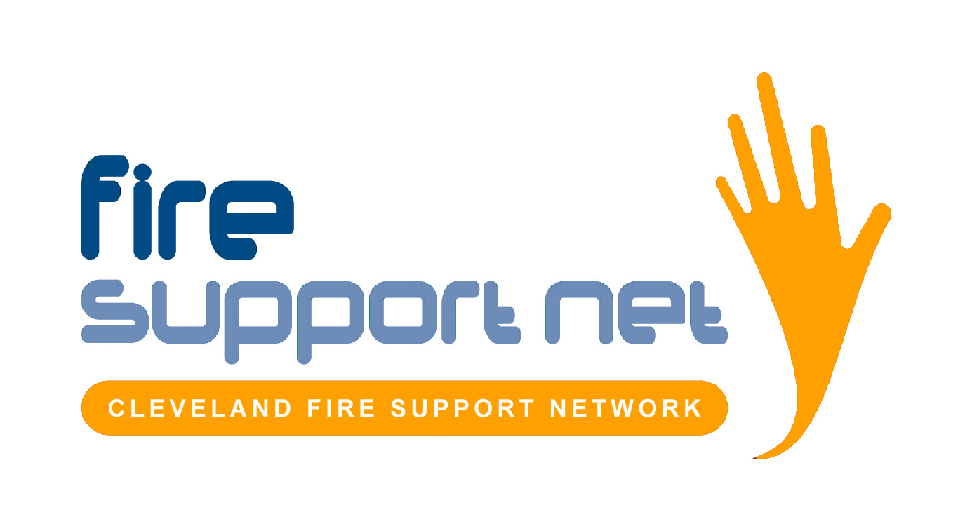

Volunteer Equal Opportunities Monitoring Information Form

Cleveland Fire Support Network is an Equal Opportunities organisation and is determined to ensure that:

- The workforce reflects the diverse society which it serves and that the working environment is free from any form of harassment, intimidation, bullying or victimisation
- All applicants (employees / volunteers) will be treated fairly and will not be discriminated against on the grounds of gender, sexual orientation, age, marital status, race, colour, nationality, ethnic or national origins, creed, religion and / or disability
- No applicant (employee or volunteer) is disadvantaged by conditions or requirements which cannot be justified by the requirements of the job

The information on this form is for monitoring purposes only and will be held on a confidential basis.

Age: 16-25 ◻ 26-35 ◻ 36-45 ◻ 46 and over ◻
Gender: Male ◻ Female ◻

Ethnic Origin:
White:
British ◻
Any other white background ◻

Mixed:
White and Black Caribbean ◻
White and Black African ◻
White and Asian ◻
Any other mixed background ◻

Asian or Asian British:
Indian ◻
Pakistani ◻
Bangladeshi ◻
Any other Asian background ◻
Black and Black British:
Caribbean ◻
African ◻
Any other black background ◻

Chinese or other ethnic group:
Chinese ◻
Any other (please specify) ◻ _______________________
Prefer not to specify ◻

Disability:
Disability is defined as ‘a medical or physical impairment which has a substantial and long-term adverse effect on the ability to carry out normal day-to-day activities’.

Do you consider yourself to have a disability? Yes ◻ No ◻

Religious Belief/Faith:
Buddhist ◻ Christian ◻
Hindu ◻ Jewish ◻
Muslim ◻ Sikh ◻
None ◻ Other (please state) ◻
Prefer not to say ◻

Thank you for your co-operation

