Redcar’s

Question Time

Election Debate
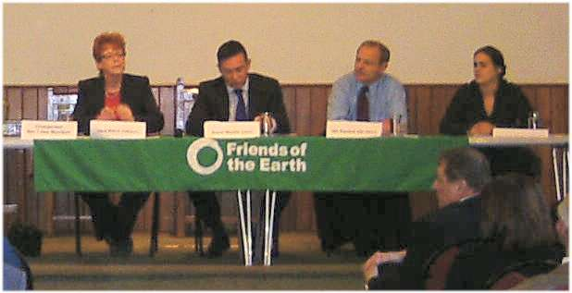

Photo from successful 2012 Redcar Hustings

Wednesday 29th April 6.45 for 7-8.30pm
Coatham Memorial Hall, 7 Coatham Road, Redcar, Cleveland TS10 1RH.

All of the Candidates. You ask the Questions! What is important to you? What are the BIG issues? The NHS, education, economy, environment, housing, defence, jobs, benefits. . .
Chaired by the Bishop of Whitby Paul Ferguson


