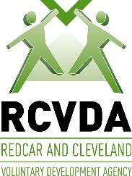

MVDA logo with tag-line.JPG

**Workshop:** Voices for Volunteer Co-ordinators Forum

Tuesday 13th March 2018 1 pm – 3 pm

**Venue:** The Grenfell Club Grant St Redcar TS10 1RW

Nearest car park Kirkleatham St TS10 1RT

Please complete a separate form for each delegate

|  |  |
| --- | --- |
| Name |  |
| Organisation |  |
| Address: |  |
| Phone: |  |
| Email: |  |

**Please note:** We will confirm your place by email (where an email address has been provided). If you have any needs to enable you to participate please contact us and we will do our best to accommodate you.

**Return this form to**: Claire Stollery, RCVDA, Westfield Farm, The Green, Dormanstown Redcar TS10 5NA by ***Wednesday 7th March 2018***

Email: [claire@rcvda.org.uk](mailto:claire@rcvda.org.uk)

*Tel:*  01642 440571