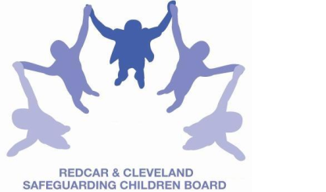
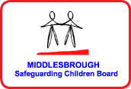

LOCAL SAFEGUARDING CHILDREN BOARD MULTI-AGENCY TRAINING
APPLICATION FORM
NEGLECT – SAFEGUARDING CHILDREN & YOUNG PEOPLE
This course will be facilitated by Neil Ventress, Independent Trainer.
TUESDAY 4th SEPTEMBER 2018
9.30am – 4.30pm
Refreshments are available to purchase from the venue at a cost of £1 for the day.
Please note that lunch is not provided at this training day.
Venue | BRIDGEWAY, ALLENDALE ROAD, ORMESBY, MIDDLESBROUGH, TS7 9LF
Aim | To raise the profile of neglect as a form of child maltreatment and to improve professional responses to children who are being neglected.
Objectives | By the end of the course participants will:  - have an increased understanding of the factors to consider when identifying neglect  - have an increased understanding of the different types of neglect and the impact that these can have on children and young people at the different stages of their development  - have an appropriate awareness of Safeguarding Children Procedures re Neglect  - appreciate the importance of personal values and attitudes in recognising and confronting neglect  - recognise the contribution that inter-agency responses can make to achieving better outcomes for neglected children and young people.
PLEASE NOTE:
- In accordance with LSCB Charging Policy this course is free to not for profit agencies in the Middlesbrough & Redcar & Cleveland area
- A non-attendance charge will be incurred if the applicant, having secured a place on the course, does not attend and their manager will be informed of their non-attendance.
- By applying to attend this course you agree to complete an evaluation on the day
and also an impact evaluation approximately 3 months after attending.
Applicant’s Details
Name
Job Title/Role
Organisation
Work Address
Telephone
E-mail

Details of applicant’s manager who agrees applicant can attend:
Name:
Telephone
Manager’s
e-mail address

Please return completed booking form to:

Email to: lscbtraining@redcar-cleveland.gov.uk
Apply online at: Apply Online for Taught Course
Post to: LSCB Training, Seafield House, Kirkleatham Street, Redcar, TS10 1SP.

If you have not heard from us within 7 working days of the course commencing please ring LSCB Training 01642 444336.

