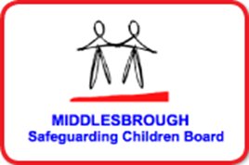
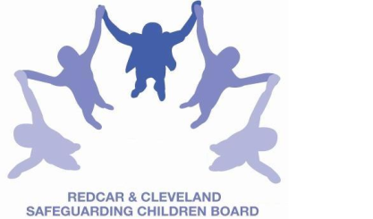

LOCAL SAFEGUARDING CHILDREN BOARD

MONDAY 6th MARCH 2017
‘Bite size’ Sessions – booking is required!

BRIDGEWAY, ALLENDALE ROAD, MIDDLESBROUGH. TS7 9LF

AIM - To raise awareness and provide information about the following issues:

09.45am- 10.45am | Opioid Substitution Therapy. Opiate Substitute Medications in Drug Treatment: Assessing and Tackling the Risks to Children, including use of the SCODA Risk Assessment  Delivered by Gina Lightwing, Specialist Addictions Nurse, Fulcrum Medical Practice and Sarah Wilson, Senior Practitioner, Stronger Families, Middlesbrough BC
I would like to attend the Opoid Substitution Therapy session |  | YES/NO  Delete as applicable

11.00 am – 12:00 noon | Awareness of Safeguarding the Unborn and New-born Baby – including Foetal Alcohol Syndrome Awareness  Delivered by Sue Taylor, Specialist Midwife Trainer, STHFT
I would like to attend the Unborn Baby session |  | YES/NO  Delete as applicable

Name:
Job Title / Role:
Your Organisation
E-mail address:

