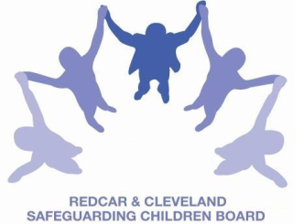
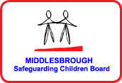
LOCAL SAFEGUARDING CHILDREN BOARDs MULTI - AGENCY TRAINING

APPLICATION FORM

Recognition and Response to Physical Abuse: Safeguarding Children & Young People
This course will be facilitated by Rachael Carter, Safeguarding Children Nurse/Trainer - South Tees NHS Trust

Date & Time | THURSDAY 13th SEPTEMBER 2018 |  |  | 09.30am to 1.00pm
Venue | Bridgeway, Allendale Road, Ormesby, Middlesbrough.  TS7 9LF
Aim | To increase understanding of safeguarding children & young people from physical abuse
Objectives | By the end of the course participants will:  - Consider the latest research findings in relation to physical abuse  - Explore thresholds of concern within a child development context  - Identify key elements for assessing risk in relation to physical abuse  - Consider the emotional impact of physical abuse on children
PLEASE NOTE:
- In accordance with LSCB Charging Policy this course is free to not for profit agencies in the Middlesbrough & Redcar & Cleveland area
- A non-attendance charge of £30 will be incurred if the applicant, having secured a place on the course, does not attend and their manager will be informed of their non-attendance.
- By applying to attend this course you agree to complete an evaluation on the day
and also an impact evaluation approximately 6 months after attending.
Applicant’s Details
Name
Job Title/Role
Organisation
Work Address
Telephone
E-mail

Details of applicant’s manager who agrees applicant can attend and that applicant has received child protection awareness training or refresher within last 3 years.
Name:
Telephone
Manager’s
e-mail address

Completed application form:
- Email to: lscbtraining@redcar-cleveland.gov.uk
- Post to: LSCB Training, Seafield House, Kirkleatham Street, Redcar, TS10 1SP

If you have not heard from us within 7 working days of the course commencing please ring LSCB Training 01642 444336.

