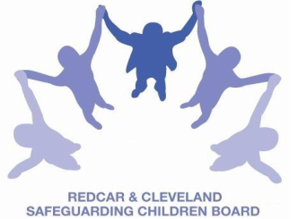
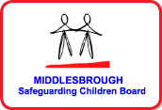

LOCAL SAFEGUARDING CHILDREN BOARD MULTI-AGENCY TRAINING
APPLICATION FORM
Safeguarding Children from Suicide and Self Harm
This half day course will be facilitated by Staff from Tees, Esk and Wear Valleys
Date & Time: |  |  | FRIDAY 14th SEPTEMBER 2018  9.30am – 1pm
refreshments available to purchase from the venue at a cost of 50p For the SESSION – LUNCH IS NOT PROVIDED
Venue |  |  | Bridgeway Project - Allendale Road, Ormesby, Middlesbrough.  TS7 9LF
PLEASE NOTE:
- In accordance with LSCB Charging Policy this course is free to not for profit agencies in the Middlesbrough & Redcar & Cleveland area
- A non-attendance charge will be incurred if the applicant, having secured a place on the course, does not attend and their manager will be informed of their non-attendance.
- By applying to attend this course you agree to complete an evaluation on the day
and also an impact evaluation approximately 3 months after attending.
Aim |  | To increase understanding of suicidal and self-harming behaviours in children and young people.
Objectives |  | By the end of the course participants will be able to:  - Have identified and explored your attitudes towards self harm & how these may impact upon your work with young people  - Be able to summarise up to date information about self harm  - Have knowledge about the multi-agency self harm protocol (Middlesbrough & Redcar & Cleveland)  - Have increased awareness of the LSCB procedures  - Understand key messages relating to suicide and self harm covered in the Biennial Analysis of Serious Case reviews
Applicant’s Details
Name
Job Title/Role
Organisation
Work Address
Telephone
E-mail
Name:
Telephone
E-mail address

Completed application form:
- Email to: lscbtraining@redcar-cleveland.gov.uk
- Post to: LSCB Training, Seafield House, Kirkleatham Street, Redcar, TS10 1SP.

If you have not heard from us within 7 working days of the course commencing please ring LSCB Training 01642 444336.

