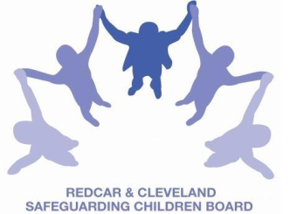
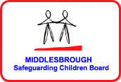
LOCAL SAFEGUARDING CHILDREN BOARD
MULTI-AGENCY TRAINING APPLICATION FORM
THE IMPACT OF PARENTAL MENTAL ILL HEALTH ON PARENTING

This one-day course will be facilitated by Sarah Mohammed, Safeguarding Children's First Contact Advisor and Trainer, TEWV
THURSDAY 27th SEPTEMBER 2018
9.30am-4.30pm

Tea and Coffee available to purchase from the venue from 9.15am, at a cost of £1 for the day
Lunch is not provided
Venue | BRIDGEWAY, ALLENDALE ROAD, ORMESBY, MIDDLESBROUGH  TS7 9LF
Aim | - To raise awareness and understanding of how parental mental health ill health can impact on parenting and to explore the impact of parental mental ill health on children.
Objectives | By the end of the course participants will achieve the following objectives:  - Have an understanding of common and serious mental health problems in adults.  - Awareness and identification of the possible effects on a child’s physical and mental health.  - Raise awareness of young carers of parents with mental health illness.  - Awareness of serious case review findings in relation to the toxic trio.  - Be confident in using the PAMIC Tool to aide decision making in relation to level of intervention.  - Know when and how to seek advice when concerns are raised about risks to children posed by parents with mental health problems.  - To know how to make a referral into Children’s Social Care.
PLEASE NOTE:
- In accordance with LSCB Charging Policy this course is free to not for profit agencies in the Middlesbrough & Redcar & Cleveland area
- A non-attendance charge of £50 will be incurred if the applicant, having secured a place on the course, does not attend and their manager will be informed of their non-attendance.
- By applying to attend this course you agree to complete an evaluation on the day
and also an impact evaluation approximately 3 months after attending.
Applicant’s Details
Name
Job Title/Role
Organisation
Work Address
Telephone
E-mail

Details of applicant’s manager who agrees applicant can attend:
Name:
Telephone
Manager’s
e-mail address

Please send completed application form to:
- Email to: lscbtraining@redcar-cleveland.gov.uk
- Post to: LSCB Training, Seafield House, Kirkleatham Street, Redcar, TS10 1SP.

If you have not heard from us within 7 working days of the course commencing please ring LSCB Training: 01642 444336.

