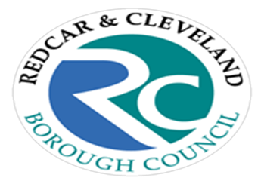

**Community Health Champion?**

**Information Sheet**

|  |  |
| --- | --- |
|  | |
|  | |
| **What are Community Health Champions?** | They are people who volunteer to inspire and motivate their friends, family and colleagues to lead healthier lifestyles. They help people access the right information and services if needed and offer simple health advice. |
| **Do I need any qualifications?** | No! You do not need any prior knowledge of health issues. You will receive initial training and you will have the opportunity to undertake further training in areas that are relevant to you. |
| **What happens after I attend a Community Health Champion Learning Day?**  **Community Health Champion?**  **Information Sheet continued…**  **Is there any support after the training?**  **Some optional activities you might like to get involved with?**  **I’m interested what do I do next?**  **For further information please contact Lesley Gibbin, Health Improvement Team**  **T: 07909 906415**  **E: Lesley.gibbin@redcar-cleveland.gov.uk** | We would like you to encourage and motivate family, friends, colleagues and community members to make positive health changes by:  Providing them with healthy lifestyle messages when opportunities arise.  Giving them information about local opportunities, activities and services such as Health Walks and Stop Smoking Services.  Encouraging them to get involved with campaigns such as Stoptober, Dry January and Couch Potato to 5K challenge  We would also like you to keep in touch and share with us any stories where people you have shared information with have made positive lifestyle changes.    Health Improvement Team will offer you support and provide you with a named point of contact who will send you regular information updates and give you access to resources if required. We also offer Community Health Champions the opportunity to attend network events at least once/year.  Run a health promotion stall alongside Health Improvement Team, set up a health promotion display in your community, train to become a volunteer Walk Leader, volunteer at local events such as Half Marathon or Triathlon  Attend one of the Community Health Champion Learning Days offered throughout the year or get together a group of interested people and we will bring the Learning Day to you. We can deliver the Learning Day over a number of weeks at a time and venue convenient to you. |
|  |  |