Dr Bill Pettit 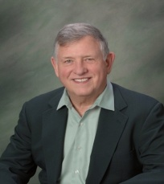t
William F. Pettit Jr., M.D., is co-owner with his wife, Linda, of 3 Principles Intervention LLC. Dr. Pettit has presented the Three Universal Principles of Mind, Consciousness and Thought as the essence of his psychiatric practice since 1983. He also practices psychiatry at the Family Medical Centre of Michigan. A graduate of Creighton University, Omaha, NE and the University of Illinois College of Medicine, Chicago, IL, Dr. Pettit completed his psychiatric residency at the Philadelphia Naval Regional Medical Centre in Philadelphia, PA. He is board-certified in Psychiatry, and has been previously certified in Adolescent Psychiatry, Geriatric Psychiatry and Psychosomatic Medicine and Addiction Medicine.
Dr. Pettit served as a physician in the United States Navy for over 9 years, including 3 years as Chief of Psychiatry of the Navy Nuclear Submarine base at Groton, Connecticut. Presently, Dr. Pettit holds an appointment as Clinical Professor at Michigan State University, College of Osteopathic Medicine, and Department of Psychiatry and also as Adjunct Professor of Counselling in the Graduate College at Siena Heights University. Formerly, Dr. Pettit held an appointment as Associate Professor of Behavioural Medicine and Psychiatry at West Virginia University (WVU) and was the Medical Director of the Sydney Banks Institute at WVU.
Previously, Dr Pettit held an appointment as Adjunct Assistant Professor at the Des Moines, Iowa Osteopathic. School of Medicine. Dr. Pettit is a recognized educator in the Three Principles intervention, and has presented at many national and international conferences and consulted to numerous clients both nationally and internationally

Dr. Linda Sandel Pettit 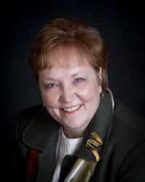

Dr Linda Sandel Pettit, counselling psychologist, is also the Dean of the Graduate College and Director of Counsellor Education in Siena Heights University, located in Michigan USA. In her role Linda oversees graduate degrees in teacher education; counsellor education; and organisational health care and higher education leadership. Before joining Siena Linda provided coaching, training, consulting and public speaking for over thirty years in private practice, hospital, community mental health, business and school settings. Linda holds a doctorate in counselling psychology, a master’s degree in counsellor education and a bachelors in journalism. Her work has been grounded in the Three Principles understanding for 10 years. She is married to Bill Pettit; they co own Three Principles Intervention LLC.

