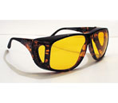
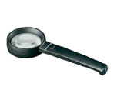

REDCAR VISUALLY IMPAIRED GROUP 2017
United Reformed Church Hall, Station Road. REDCAR 10.00 – 12.00

JANUARY 27TH GOLF (Redcar Golf Club)
FEBRUARY 24TH RNIB Speaker followed by IT session
MARCH 31ST Visit to Mayor`s Parlour
APRIL 28TH TBA
MAY 26TH BOWLS
JUNE 30TH TBA
JULY 28TH TBA
AUGUST 25TH TBA
SEPTEMBER 29TH TRIP
OCTOBER 27TH BOWLS
NOVEMBER 24TH CHRISTMAS LUNCH
These are proposed activities for the year and may change
If you are visually impaired or care for someone who is, join us on the last Friday of the month for fun activities and a cuppa.
Contact Irene Poynter 01642 470912
email irenepoynter@icloud.com

