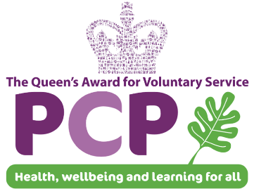


Pioneering Care Partnership
Recruitment Advert

Healthwatch County Durham is the independent consumer champion for Health and Social Care. We gather patient and the public’s opinions about the services they use and make recommendations to make them better. Healthwatch County Durham is looking for an organised and enthusiastic team player to join our successful team as:

Communications and Administrative Officer
Healthwatch County Durham, Durham-Meadowfield Industrial Estate/home working
with occasional outreach work
30 hours per week
PCP Band 4 £19,976 per annum, pro rata, fixed term until March 2022 (with possible extension)

Job Purpose: To maintain a digital presence to increase the awareness and visibility of Healthwatch across County Durham and the region with communities and stakeholders and to carry out varied admin tasks to support the smooth running of all Healthwatch activities.

Key tasks:
- To support the development and implementation of a communications strategy that incorporates communication channels including WhatsApp, Webinars, social media, blogs, newsletters and traditional media to suit different community needs, to increase visibility and stakeholder engagement.
- To deal with enquiries relating to Healthwatch in a professional, courteous and prompt manner.
- To provide effective and efficient administrative support for Healthwatch County Durham.
- To support the Healthwatch Chair and Board members by preparing their meeting papers, arranging meetings and collating needed information, including desktop research.
- To maintain the Healthwatch website, newsletter distribution and marketing materials.
- To help to organise annual events and other engagement activities.

Key skills required: Excellent communication and people skills, an interest in supporting volunteer Board members and a real desire to work as part of a team. Good organisation and IT skills and the ability to manage a varied workload with a positive and flexible approach.
If you would like to know more about this exciting opportunity and would like an application pack, please contact the HR Department on:
Telephone: (01325) 313133  Email: hr@pcp.uk.net | Or download it from our Website:  www.pcp.uk.net

Please note that the Pioneering Care Partnership does not accept CV’s as part of the application process.

Closing Date for applications: Midday on Monday 8th November 2021
Interview date 19th November 2021

We are an equal and diverse employer and particularly welcome applicants from groups who are currently underrepresented at PCP, such as males, people with sensory impairments and carers





Registered Office: Pioneering Care Partnership, Carers Way, Newton Aycliffe, Co. Durham, DL5 4SF. Registered Charity No. 1067888. Company Limited by Guarantee. Company Registered in England No: 3491237.

