 | 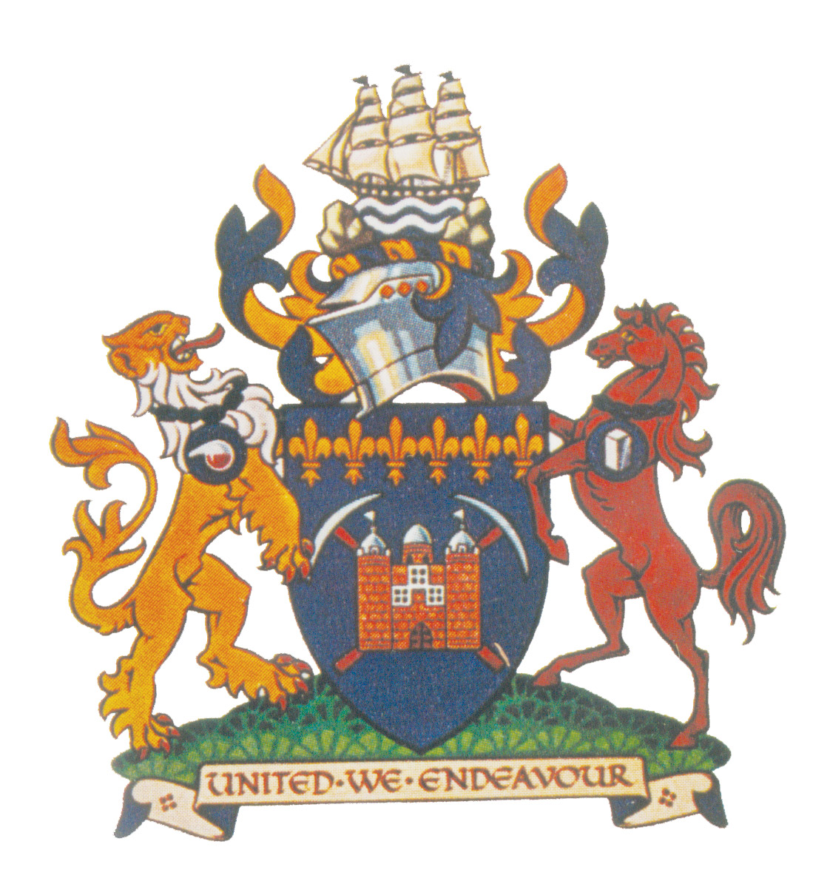 |  | Redcar & Cleveland Borough Council  The Mayor’s Office
 |  |  | Leisure and Community Heart
 |  |  | Ridley Street
 |  |  | Redcar
 |  |  | TS10 1TD
 |  |  | Telephone: 01642 444501
 |  |  | Email: jane.holmes@redcar-cleveland.gov.uk
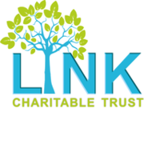 |  | Rubies Charity  

Dear Sir/Madam

My name is Carole Morgan and I am the current Mayor of Redcar and Cleveland for 2021/2022.

I have chosen two local charities to support during my Mayoral year, the Link Charitable Trust and Rubies. I have visited both charities and have seen the tremendous support they offer to the young people in our local community.

I have fund raising events planned throughout the year and am in the process of organising a charity night where there will be a raffle to win some fantastic prizes. I have enclosed a leaflet of the event for your information.

I am asking for support from businesses by way of prize donations to make the raffle a success and generate much needed funds for the two charities.

I appreciate that there are a lot of charities requesting fundraising help and completely understand if you are unable to donate a prize.

If you would like to donate a prize of any value, you can contact Jane Holmes on 01642 444501 (email as per above) or myself on 07717 423757.

Thank you for taking the time to read this letter.

Yours sincerely
Councillor Carole Morgan

Mayor of Redcar & Cleveland

