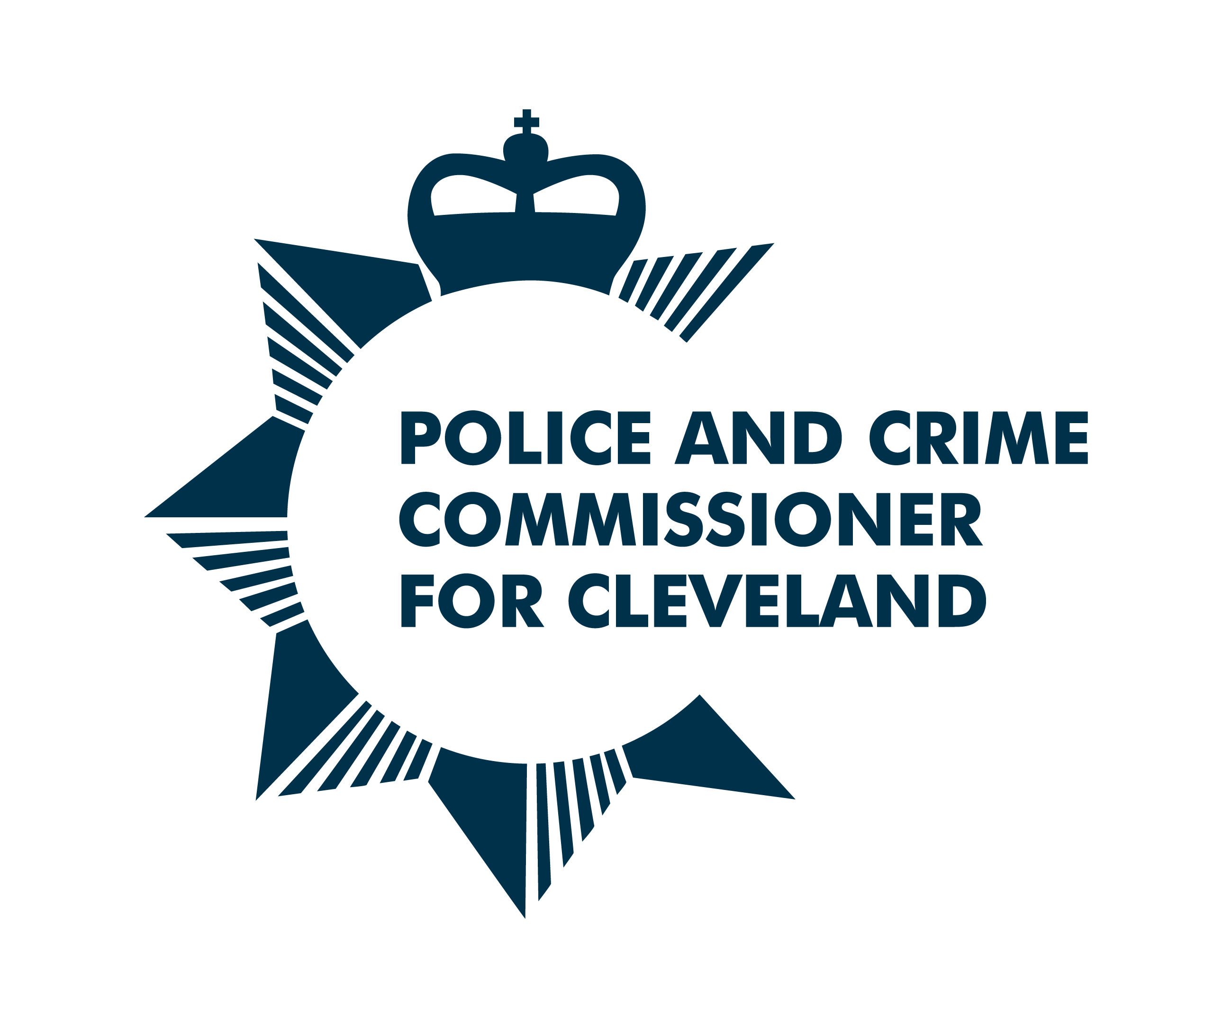

Cleveland Youth Commission on Police and Crime 2021: Application Form

We are looking for applications from 14-25 year olds who are currently residents of Cleveland – including Hartlepool, Stockton, Middlesbrough, Redcar and Cleveland
Section 1: Your details

NAME:

DATE OF BIRTH:

HOME ADDRESS:
POST CODE:
EMAIL:
LANDLINE:
MOBILE:

If you are selected, we would like the ability to be able to connect with you via social media. Please provide your social media handles below.

TWITTER:
FACEBOOK:
INSTAGRAM

CURRENT OCCUPATION (Student at school, college, university, in work, unemployed):

NAME OF YOUR SCHOOL/ COLLEGE/ UNIVERSITY/ YOUTH ORGANISATION/EMPLOYER ORGANISATION:

NAMED PROFESSIONAL WHO WOULD SUPPORT YOUR APPLICATION AND THEIR ORGANISATION (This could be a teacher, youth worker, tutor, lecturer, manager):

If you are under 18 years old, please ask your parent/guardian/carer to provide the following details too. We will require written permission from them before we can confirm your place.

NAME OF PARENT/GUARDIAN/CARER:
HOME ADDRESS:
POST CODE:
EMAIL:
LANDLINE:
MOBILE:

Section 2: More about you

- Why do you want to join the Cleveland Youth Commission on Police and Crime?

- Why do you think you should be selected for the Cleveland Youth Commission on Police and Crime?
For example, you might have specific skills, knowledge or life experiences that you’d like us to know about.

- Please tell us about yourself. Use up to 50 words to sum up your personality, interests, experiences or strengths. (Please stay within the word limit.)

Section 3: Your availability Please Note: We are following the UK Government current recommendations on the covid-19 virus. This means until the UK Government relaxes the ‘safe at home rule’, we will be holding members meetings digitally online. We will give you more details closer to the time.

- We will be holding the first Youth Commission Priority sessions on: Friday 13th August 2021

Are you available to attend? Yes [ ] No [ ]

- We will be holding the second Youth Commission session on: Saturday 11th September 2021

Are you available to attend? Yes [ ] No [ ]

Section 4: Diversity monitoring information

Leaders Unlocked and the Cleveland Police and Crime Commissioner are committed to promoting equality and diversity. We invite you to complete this section of the application form so that we can monitor and analyse information about the diversity of the people who submit an application. Any information you provide will be treated as strictly confidential. It will not be shared or used by anyone directly involved in the selection process. We will transfer all the information provided into a database and then destroy all individual forms. No information will be published or used in any way that allows any individual to be identified. You are not obliged to answer the questions on this form. If you do not wish to answer a question simply answer ‘Prefer not to say’.

- Your Gender (please put an X in the appropriate box)

Male Female Non binary Prefer not to say

- Gender Identity Does your gender differ from the biological sex you were assigned at birth?:

Yes No Prefer not to say

- What is your preferred pronoun?

He/Him She/Her They/Them Xe/Xim Other

- Your sexual orientation (please put an X in the appropriate box)

Bisexual Gay man Gay woman/lesbian

Heterosexual Other Prefer not to say

- Your religion or belief (please put an X in the appropriate box)

None Buddhist Christian

Hindu Jewish Muslim

Sikh Any other Prefer not to say

- Your ethnic origin (please put an X in the appropriate box)

White

British English Welsh Scottish

Northern Irish Gypsy or Irish Traveller Other

Mixed/multiple ethnic background

White and Black Caribbean White and Black African

White and Asian Any other/ multiple ethnic background

Asian/Asian British

Bangladeshi Chinese Indian Pakistani

Any other Asian background

Black/African/Caribbean/Black British

African Caribbean

Any other Black/African/ Caribbean background

Other ethnic group

Arab Any other ethnic group Prefer not to say

- Do you consider that you have a disability?

Yes No Prefer not to say

Section 5: When will I hear back?

We will conduct interviews with shortlisted candidates on the phone. All successful applicants will be informed by 6th August 2021
If you have any other questions about the application process, please email Kaytea Budd-Brophy at kaytea@leaders-unlocked.org

Please email your application forms back by - 27th July 2021
to: gabrielle@leaders-unlocked.org

Section 6: How will you protect my privacy?

Your privacy is really important to us. By filling in the Cleveland Youth Commission application form, you are consenting to Leaders Unlocked using your personal information to keep in touch with you over the course of the project. If your application is not successful, or you decide to withdraw your application, we will delete your personal data from our files.

If you want to withdraw your consent at any time you can contact the Data Protection officer at info@leaders-unlocked.org and if you would like to see our full Privacy Notice you can do so here http://leaders-unlocked.org/wp-content/uploads/2018/05/Leaders-Unlocked-Privacy-Notice-May-2018-1.pdf

We look forward to receiving your application!

