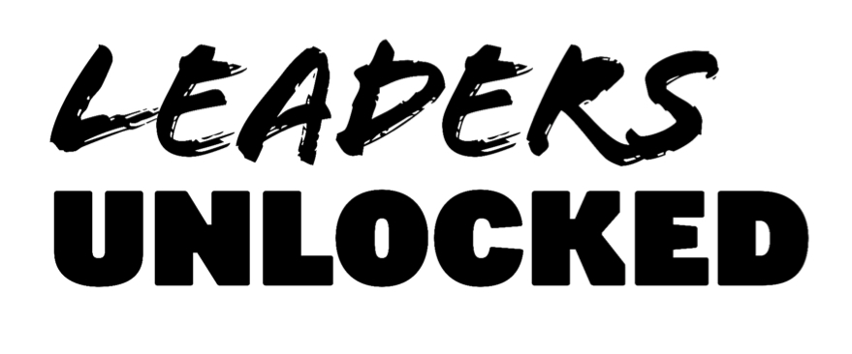
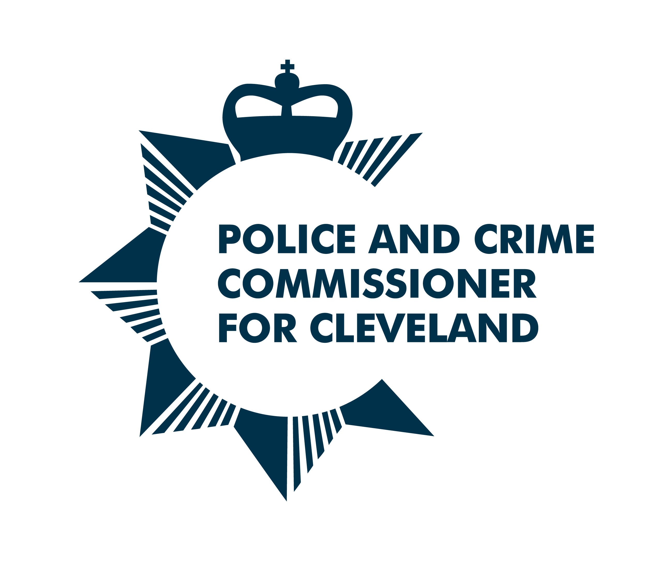
Cleveland Youth Commission on Police and Crime 2021
CONSENT FORM
If you are under 18, please ask a parent/guardian/carer to complete and sign this form. Please make sure they have read the Application Guidance Notes and understand what’s involved in the project.

I consent to [NAME] ………………………………………………………………………………………… becoming a member of Cleveland Youth Commission on Police and Crime in 2021/22
Parent/guardian name (PRINT) …………………………………………………………………………………………………………………
Parent/guardian signature………………………………………………………………………………………………………………………..
Relationship to applicant …………………………………………………………………………………………………………………………
Date…………………………………………………………………………...................................................................................
Contact telephone number……………………………………………………………………………………………………………………….
E-mail……………………………………………………………………………………………………………………………………………………….
This form can be photographed/scanned and emailed to: gabrielle@leaders-unlocked.org
Privacy: Your privacy is really important to us. By filling in the Cleveland Youth Commission application form, you are consenting to Leaders Unlocked using your personal information to keep in touch with you over the course of the project. If your application is not successful, or you decide to withdraw your application, we will delete your personal data from our files.
If you want to withdraw your consent at any time you can contact the Data Protection officer at info@leaders-unlocked.org and if you would like to see our full Privacy Notice you can do so here Leaders-Unlocked-Privacy-Notice

