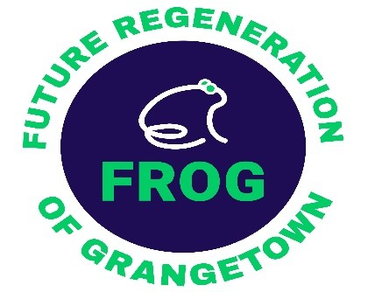
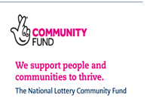

Key duties and responsibilities
The post requires the necessary skills and experience to support your clients by providing quality, independent information and advice to help them address their problems and prevent them from getting worse.
To ensure a holistic package of support can be provided. The post holder will develop close links with other support services.
- To provide practical help such as writing/typing letters and helping clients fill in forms, carry out back to work calculations and things such as entitlement to particular benefits.

- Initial point of contact from within the Grangetown United Community Hub and outreach across Redcar and Cleveland for those seeking help with debt, arrears with rent or mortgage who are at risk of homelessness.

- Clients may present with a single issue or more complex linked problems that require specialist support. To develop a close working partnership with Citizens Advice, Foot Prints in the Community, Community Bank, Warm and Well and Housing.

- To build a network of referral services to support clients with further help if needed to ensure other issues such as the clients mental health can be addressed.

- Represent your client where necessary - this may involve contacting key partner agencies e.g. CAB, other financial institutions, housing providers or the legal system.

- To maintain confidential record of client cases, write reports and compile statistics on cases covered and services provided.

- To keep up to date with appropriate legislation and policies.

- To work closely with the project enterprise manager and finance officer to ensure the outcomes of the project are met.

- To demonstrate a commitment when carrying out their duties which promotes the equality of opportunity in relation to service users which is in line with FROG Equality & Diversity Policy.

