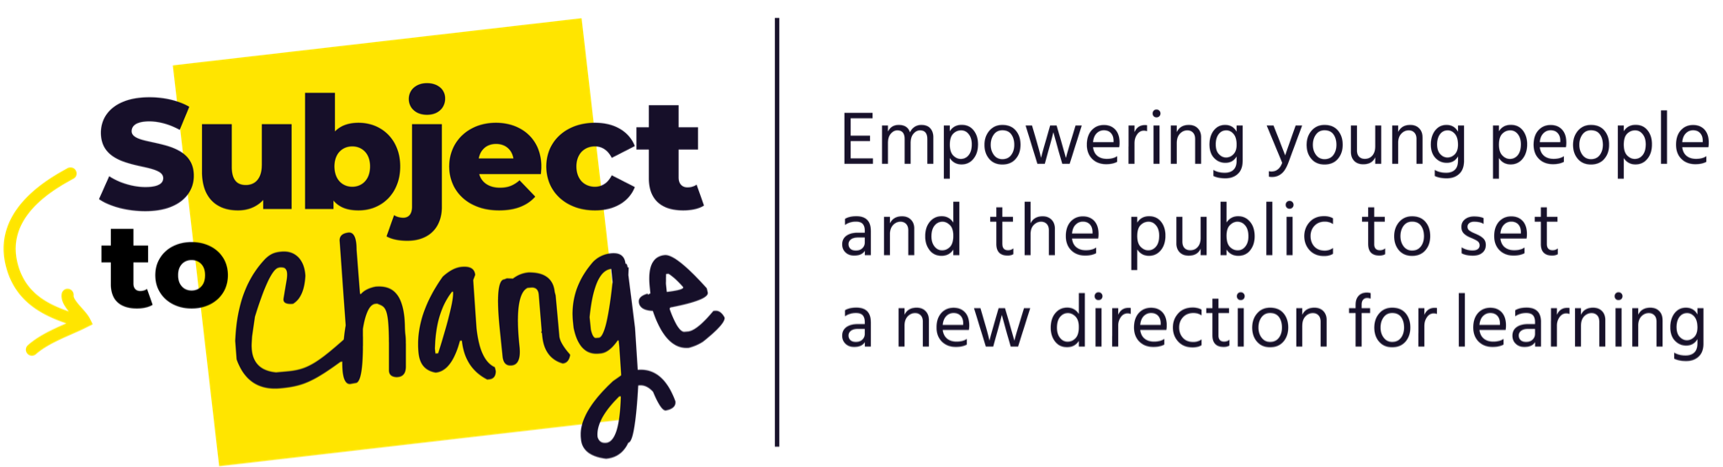
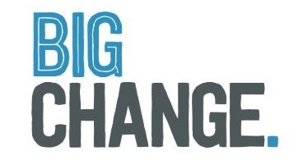

Subject to Change Project Council: Empowering young people and the public to set a new direction for learning

Application form

We are looking for applications from 11–18-year-olds who are currently living anywhere in England.
Section 1: Your details

Name:
Date of birth:
Home address:
Postcode:
Email:
Phone:

Name of your school/ college/ youth organisation/ employer:

Named professional or adult, e.g. teacher or youth worker, who will support your application: (If you’re unsure, leave this blank and we can discuss with you at the next stage)
If you are under 18, please ask your parent/guardian/carer to provide the following details. We will require written consent from them before we can confirm your place.

Name of parent/guardian/carer:

Home address:
Postcode:
Email:
Phone:
Section 2: Different ways to apply

There are different ways to apply for this opportunity! We want you to choose the option that suits you best. Please select one of the options below:

In writing – please provide your written answers below in section 3

With video – please send us a short video to respond to the questions in section 3

With imagery/art – please send us an image file to respond to some or all of the questions in section 3

With creative writing/ poetry – please send us word document to respond to some or all of the questions in section 3

By phone – if you select this option, one of our team will get in touch with you by phone to guide you through the questions and gather your responses

Please note: Any video files, image files or creative writing should be emailed to abdul-moiz@leaders-unlocked.org and should have your name in the title. If the files are too big to send as attachments, please use ‘We Transfer’ to transfer them.

Section 3: Written answers

If you would like to apply in writing, please write your answers below.

- Tell us a bit about yourself! Use up to 50 words to sum up your personality, interests or passions.

- Expression of Interest – What are your motivations for joining the ‘Subject to Change’ Project Council? Feel free to express this however you’d like to!

- What do you think you’d bring to the ‘Subject to Change’ Project Council? For instance, you might have particular life experiences, skills or knowledge that you’d like to tell us about.

- What’s one big change you would like to see in the education system? We’re interested in all ideas, no matter how big or small.

Section 4: Your availability

We are aiming to hold a Welcome meeting on Zoom on Tuesday 12th April at 5pm – 7pm

Are you available to attend? Yes [ ] No [ ]

We are aiming to hold the second Project Council meeting on Saturday 7th May from 12pm – 4pm in London (travel will be arranged)

Are you available to attend? Yes [ ] No [ ]

Please note: If you are not available to attend these dates, don’t worry, we’d still like to receive your application! We understand that some of you may have exams coming up, we’re very open to ensure we can work around them.

Section 5: Diversity monitoring information

Leaders Unlocked and Big Change are committed to promoting equality and diversity. We ask you to complete this form so that we can monitor and analyse information about the diversity of the people who apply. Any information you provide will be treated as strictly confidential. We will transfer all the information provided into a secure database and then destroy all individual forms. No information will be published or used in any way that allows any individual to be identified. You are not obliged to answer the questions on this form. If you do not wish to answer a question simply answer ‘Prefer not to say’.

- Your gender (please put an X in the appropriate box)

Male Female Non-binary

Prefer not to say

If you prefer to use your own term, please specify here:

- Your sexual orientation (please put an X in the appropriate box)

Bisexual Gay man Gay woman/lesbian

Heterosexual Other Prefer not to say

If you prefer to use your own term, please specify here:

- Your religion or belief (please put an X in the appropriate box)

None Buddhist Christian

Hindu Jewish Muslim

Sikh Prefer not to say Other

If you have another religion or belief, please specify here:

- Your ethnic origin (please put an X in the appropriate box)

Ethnic origin is not about your passport or where you were born. It is about your identity and how you feel. Please put an X in the appropriate box
White

British English Welsh Scottish

Northern Irish Gypsy or Irish Traveller Other

Any other white background, please write in:

Mixed/multiple ethnic background

White and Black Caribbean White and Black African

White and Asian

Any other mixed background, please write in:

Asian/Asian British

Bangladeshi Chinese Indian Pakistani

Any other Asian background, please write in:

Black/African/Caribbean/Black British

African Caribbean

Any other Black/African/Caribbean background, please write in:

Other ethnic group

Arab Prefer not to say

Any other ethnic group, please write in:

- Do you consider that you have a disability?

Yes No Prefer not to say

The information in this form is for monitoring purposes only. If you believe you need support during the recruitment process or a ‘reasonable adjustment’ to be a part of the Project Council, then please reach out to Moiz at Leaders Unlocked who is coordinating the recruitment process (abdul-moiz@leaders-unlocked.org).

Section 6: What are the next steps?

Please email your completed application form (and any supporting files) to abdul-moiz@leaders-unlocked.org by Friday 18th March 2022

Once we receive your application, we will carry out telephone interviews with a shortlist of applicants. All applicants will be informed by March 25th whether they have been selected for an interview.

Section 7: How will you protect my privacy?

Your privacy is really important to us. By filling in this application form, you are consenting to Leaders Unlocked using your personal information to keep in touch with you over the course of this project. If your application is not successful, or you decide to withdraw your application, we will delete your personal data from our files. We will not share your data with people outside of the project team.

If you want to withdraw your consent at any time you can contact the Data Protection officer at info@leaders-unlocked.org.

To read our privacy statement please go to http://leaders-unlocked.org/wp-content/uploads/2018/05/Leaders-Unlocked-Privacy-Notice-May-2018-1.pdf

Privacy information can be a bit confusing sometimes. Please get in touch if you’d like to discuss or go over any information.

We look forward to receiving your application!

