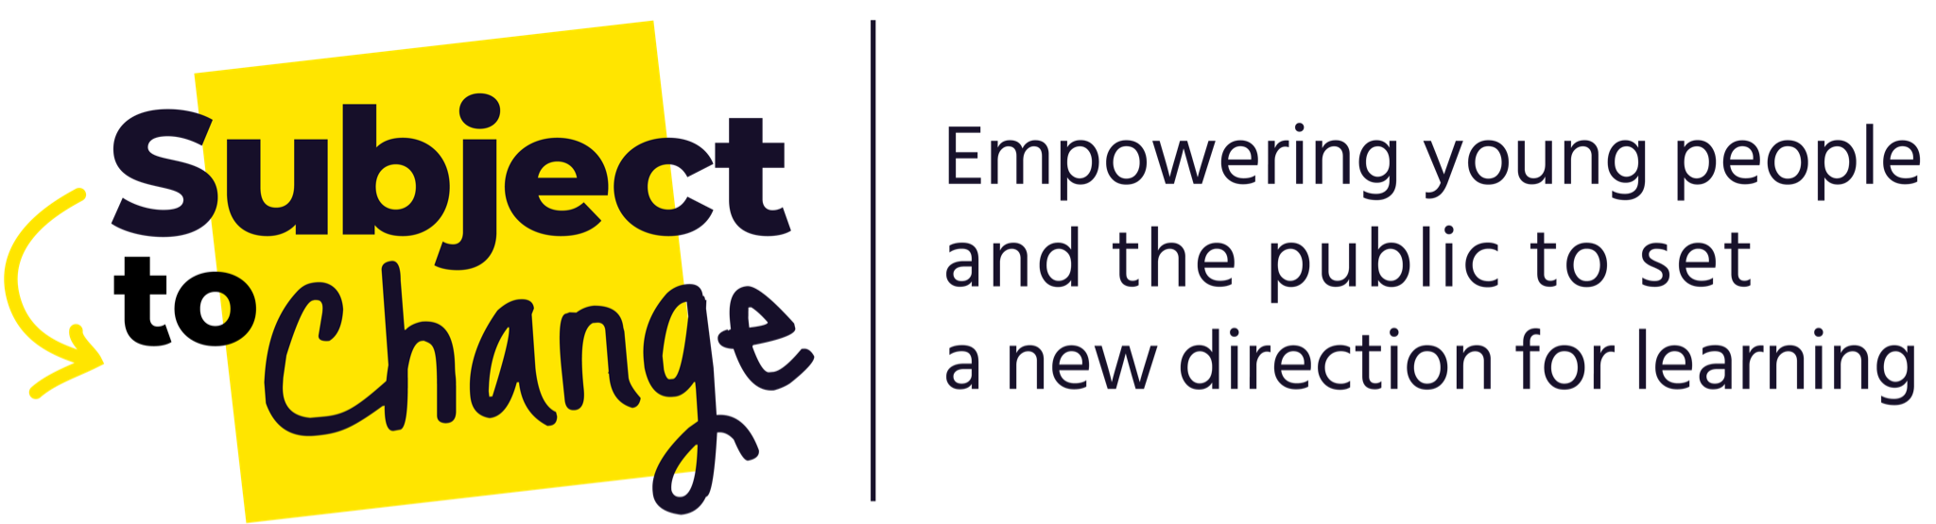
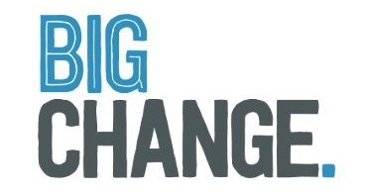

Subject to Change Project Council: Empowering young people and the public to set a new direction for learning

Frequently Asked Questions: Please read before applying

- What is the Subject to Change Project Council?
The Subject to Change (STC) Project Council will enable young people to play a leading role in a new national project to change education.
Project Council Members will:
- Get empowered and supported to be a part of setting a new direction for learning and advocate for changes that will make a difference to young people across the country.
- Gain opportunities for personal development – through skills training, mentoring and valuable experience.
- Work alongside experts involved in Subject to Change to provide advice and ideas from a youth perspective.
- Influence policy ideas and actions to transform the education system in England.
- Co-produce communications and projects that reflect the needs and aspirations of young people.

- Who’s involved?

Subject to Change is a national project combining insight, action and public engagement to set a new direction for learning. The Project Council will influence all aspects of Subject to Change, and ensure that young people are at the heart of it.
Subject to Change is a project founded by Big Change and IPPR, in partnership with a group of funders and other expert partners. Big Change is a charity that aims to shape a society where every young person is set up to thrive, in life not just exams. IPPR, the Institute for Public Policy Research, is the UK's leading progressive think tank.

The Project Council will be recruited and facilitated by Leaders Unlocked, a social enterprise that enables young people to have a stronger voice and influence over the issues that affect their lives.

For more information, please feel free to read the Subject to Change report: STC Report
3. Who can join the STC Project Council?
We are looking for young people aged 11-18 who are living anywhere in England. In total, we are planning to select 20-25 people to join the Project Council from a range of local areas, backgrounds and life experiences.
We are looking for young people with a variety of experiences in the education system. This can include but isn’t limited to:

- Pupil Referral Units or Alternative Provision
- Specialist Schools & Colleges for students with additional needs
- School exclusion
- Being in the care system
- Positive educational experiences
- Independent schools
- Boarding schools
- Home education

We are looking for young people who are team players and willing to get involved with all the events and activities that are part of the STC Project Council (see the next page for more information).

- What will I get from being part of the STC Project Council?
- Collaborate with professionals and experts: You will work alongside professionals and experts from Big Change, IPPR and other organisations. You will help them to understand what young people’s perspectives are and collaborate to develop ideas and actions.
- Develop your knowledge, skills and experience: You will gain valuable skills and experience, including leadership and public speaking skills. We will support you with your personal goals throughout the project. You will be able to use this experience for your CV, and when applying for jobs or courses.
- Meet new people: You will work alongside other young people living across England who are also passionate about making changes in the education system. You will connect with a range of professionals with expertise in different areas, and have a great opportunity to build your relationship with them.

- Make a real difference: You will have the chance to influence policy recommendations and actions to transform the education system. You will be involved in developing new ideas and solutions that will benefit young people in communities across England. Your vision and work will be supported to set a new direction for education and learning.

- If I join, what will I have to do?
Between April 2022 and April 2023, members of the STC Project Council will:
- Take part in Project Council sessions: You will take part in roughly one session each month. Each session will be 2-3 hours in length, depending on the content. Most of the sessions will take place online, and we will offer support if you need help joining an online meeting. There will be some sessions that will take place in person and we will support you with travel and practicalities.
- Take part in skills training: You will be given practical training to build key skills such as public-speaking, facilitation and chairing, interviewing and research techniques. As a Council, you will have the chance to choose from a ‘menu’ of training opportunities and tell us what matters most to you.
- Influence the project’s big decisions: You will get involved with activities across the whole project. For example, as a Council you will have the opportunity to shape and create campaigns (engagement), conduct research (insight) and help decide where money is spent to have the most impact (action).
- Help to shape the way Big Change and partners work in the future: We’ll bring together staff from Big Change, IPPR and other organisations to hear from the STC Project Council and your recommendations will influence the way they work with young people in the future.
- Is this a paid or voluntary opportunity? Will the cost of my travel be covered?
Your involvement in the Project Council will be voluntary, however, we will be reimbursing Project Council members for their commitment throughout the year, in line with principles from the Living Wage. We will work with each of you to make sure this is done appropriately, taking into consideration your individual circumstances.

We plan to hold some face-to-face events at key points during the year. We will pre-book your train travel to London for these events. We can cover any other travel expenses in cash on the day of the event, as long as you bring your receipts with you. We will provide all the food and refreshments for events and will do our best to accommodate any dietary requirements you might have.
- How do I apply?
You should complete the application form to provide your key information (e.g. Address, date of birth, contact details and diversity information)
As a part of this form, you will be asked to choose how you want to apply. There are 5 options and you can choose what suits you best:
- In writing: To apply in writing, you can complete written answers using the application form mentioned above. These are the questions on the application form.
  - Tell us a bit about yourself!
  - What are your motivations for joining the ‘Subject to Change’ Project Council?
  - What do you think you’d bring to the ‘Subject to Change’ Project Council?
  - What’s one big change you would like to see in the education system?
- Video: To apply with a video, you can create a short video (no more than 3 mins) to tell us who you are, why you want to join the Council, what you hope to bring to it and what change in education you’d like to see. Please email your video file with your name in the title to abdul-moiz@leaders-unlocked.org (you can use We Transfer if the file is too big to email)
- Imagery/art: To apply with imagery, you can create a collage or piece of artwork to tell us who you are, why you want to join the Council and what you hope to bring to it. Please email your image file with your name in the title to abdul-moiz@leaders-unlocked.org (you can use We Transfer if the file is too big to email)
- Creative writing/ poetry: To apply with poetry, you can write this in a word document to tell us who you are, why you want to join the Council, what you hope to bring to it and what change in education you’d like to see. Please email the word document file with your name in the title to abdul-moiz@leaders-unlocked.org
- Phone: To apply by phone, you can select this option in the online form and we will contact you to arrange a time to gather your answers by phone.
The deadline for applications is Friday 18th March 2022. Please fill in the application form and email any additional files to abdul-moiz@leaders-unlocked.org by this date. If you have any questions or would like any support with the application form, you can get in touch with Moiz by email or by phone on 07752614117.
8. What happens next?

Once we have received all applications, we will carry out telephone interviews with a shortlist of applicants. We’ll tell you whether you have been selected for an interview by March 25th.

Remember: please email your completed application form and any supporting files to abdul-moiz@leaders-unlocked.org
GOOD LUCK WITH YOUR APPLICATION!

