

**W H Y Y O U S H O U L D**

**V O L U N T E E R W I T H A G E U K T E E S S I D E**

Volunteers are an integral part of the Age UK Teesside team, working tirelessly to support our services and our clients. With a variety of volunteering opportunities available, there’s a role to suit everyone.

Read on to learn about all of our roles, including quotes from our current volunteers, plus some thoughts from our service users and how they feel about the volunteers they interact with.

##### FAQ's

Is there an age limit & how much time must I commit to giving?

Volunteers must be aged over 18, but there is no upper age limit, other than for drivers who must be under 70. You can commit as many hours as you wish from a minimum of two hours per week.

Can I claim expenses?

All reasonable travelling expenses incurred in carrying out your volunteering duties will be reimbursed.

A DBS check will be required for all voluntary posts.

The purpose of this role is to offer support and friendship to those over 65, through positive one-to-one relationships, to older people in their own homes. The aim of the befriending role is to enable older people to achieve outcomes which are meaningful to themselves by facilitating social interaction, building self-esteem and confidence. We also hope to motivate clients to access social activities and services in their community.

Location and duration:

At service users home or in an Age UK Teesside group setting. Minimum volunteering required is 2 hours per week.

This role involves:

Call in and visit with an older person in their own home Accompany clients on short walks, outings or activity groups.

The following requirements from volunteers who want to take this opportunity are:

**Essential**: Enthusiasm, reliability, flexibility, outgoing personality, good listening skills.

**Desirable:** Previous experience working with older people, or those with disabilities/long-term health problems.

If you would like to discuss this role further, please contact the team leader for your area:

Stockton-on-Tees: Call **Gill** on 01642 433 728 Redcar & Cleveland: Call **Sandra** on 07921 464114 Middlesbrough: Call **Paula** on 01642 433725

The purpose of this role is to offer support and friendship, through positive one-to-one relationships, to the cared for in their own homes. The aim of the volunteer role is to enable carers to have a short break whilst the cared for benefits from social interaction. We also hope to motivate carers and the cared for to access social activities and services in their community.

##### Location and duration:

At the cared for’s home. Minimum volunteering required is 3 hours per week.

This role involves:

Call in and visit the cared for in their own home Provide company and conversation

Accompany clients on short walks, outings or activity groups.

The following requirements from volunteers who want to take this opportunity are:

**Essential:** Enthusiasm, reliability, flexibility, outgoing personality, good listening skills.

**Desirable:** Previous experience working with people with disabilities or long term health conditions

If you would like to discuss this role further, please contact Redcar & Cleveland: **Marie Kerr** 07834 181 190 or email [marie.kerr@ageukteesside.org.uk](mailto:marie.kerr@ageukteesside.org.uk)

Middlesbrough: **Helen Metcalfe** 01642 80 55 00 or email [helen.metcalfe@ageukteesside.org.uk](mailto:helen.metcalfe@ageukteesside.org.uk)

Walk Leaders Walk Assistants

Age UK Teesside have multiple weekly walks arranged across Teesside which support physical health and social interaction amongst those who take part. With several walks already launched across Middlesbrough, Stockton-on-Tees and Redcar & Cleveland, we are hoping to add more events and more routes as we welcome the warmer weather.

### Walking Locations:

Marske Locke Park Stewart Park

Hemlington Lake Ropner Park Tees Barrage Preston Park Fairy Dell

Yarm Town Hall And more....

Walk Leaders are in charge of the groups—leading the walk and planning the route ahead of time, ensuring it is safe for those walking.

Walk Assistants support the Leader and oversee the walkers. FULL TRAINING IS PROVIDED

Call 01642 805500 for more information

### Online Sales Champion

Our Online Sales Champions are responsible for not only the sorting of donations, the researching of the items in order to get the best prices and the listing of these onto the selling platforms we use (including Ebay and Gumtree) but they will be learning new skills, meeting new people and making a difference to people's lives in the region through the sales achieved.

### Sorters

Sorters can volunteer as little as a couple of hours a week, helping to sort donated items for either resale or recycling. As we have limited storage space, sorters are also vital for helping to organise our retail office and storage room.



Contact Neil today on 07398 840453 for more information or email [Retail@Ageukteesside.org.uk](mailto:Retail@Ageukteesside.org.uk) to apply

Digital Explorers (Redcar & Cleveland)

Digital Explorers is a digital inclusion project aimed at helping people over the age of 50 in Redcar and Cleveland gain the confidence and skills to use digital platforms to enhance their lives.

Rekindle (Middlesbrough)

Rekindle is a digital inclusion project aimed at helping people over the age of 60 in Middlesbrough gain the confidence and skills to use digital platforms to enhance their lives.

The project aims to tackle the issues of loneliness and isolation and improve wellbeing. Rekindle can help absolute beginners as well as people who have made a start and got confused.

The project can provide group sessions in a social setting or one to one support.

We are looking for enthusiastic individuals with an interest in technology.

You will be teaching people the basics of navigating the Internet and how to access online services.

A basic knowledge of computers, phones, apps and social media and minimum commitment of 2 hours per week.

Training will be given and expenses reimbursed.

For more Digital Explorers, please contact Neil Bankhurst on: 07398 840453 or [neil.bankhurst@ageukteesside.org.uk](mailto:neil.bankhurst@ageukteesside.org.uk)

For Rekindle, please contact Steve Thompson on:

##### 07921 464108

The purpose of this role is to support social groups, serving refreshments and/or hot beverages, assisting the project leader and socialising with the group members.

Possible volunteer duties: Quiz master

Bingo caller Beverage maker

Current/Future groups:

Lunch & Social (with board games) Arts & Crafts

Friendship Friday (with bingo and quiz) Carpet Bowls

Gardening/Allotments

*Groups are still suspended due to COVID restrictions. Volunteer roles will be limited when groups are reinstated but we look forward to welcoming new volunteers to support larger groups when we are able.

Call 01642 805500 for more information



‘’Befriending is such a rewarding thing, which requires little effort and it means such a lot to people’’

‘’AUKT point you in the right direction’’

# ‘’Befriending is just a chat with someone who has the same interests as me’’

## ‘’Just one hour a week is really something to look forward to’’

#### ‘’It’s not difficult- it’s so easy and if you like talking and drinking tea then why wouldn’t you?’

‘’For a couple of hours a week we are in our own bubble – we can forget about what’s going on in the outside world and enjoy our shared interests’’

‘’My client and I are so different, with very little in common, but somehow it works and we are the best of friends’’



"I really like my befriender, she is a breath of fresh air"

"I was given all the information I needed to get the support for my husband and myself."

"John’s visits have kept me entertained. We’ve chatted about so much in recent weeks"

# "I sometimes can’t be bothered to get out of bed. The day Carol visits is different"

## "I’m getting out more since Malcolm has been visiting. I knew I could do it but I just didn’t have the confidence."

"Tracey is great. I’ve been out and about more and feel like my life has a bit more going on now. New company, chatting, popping out for a coffee – I really enjoy it"

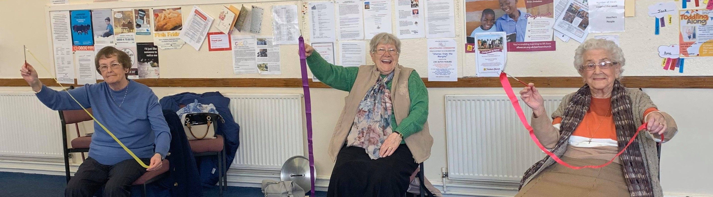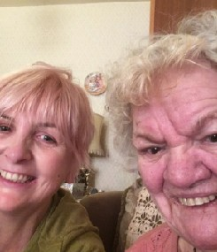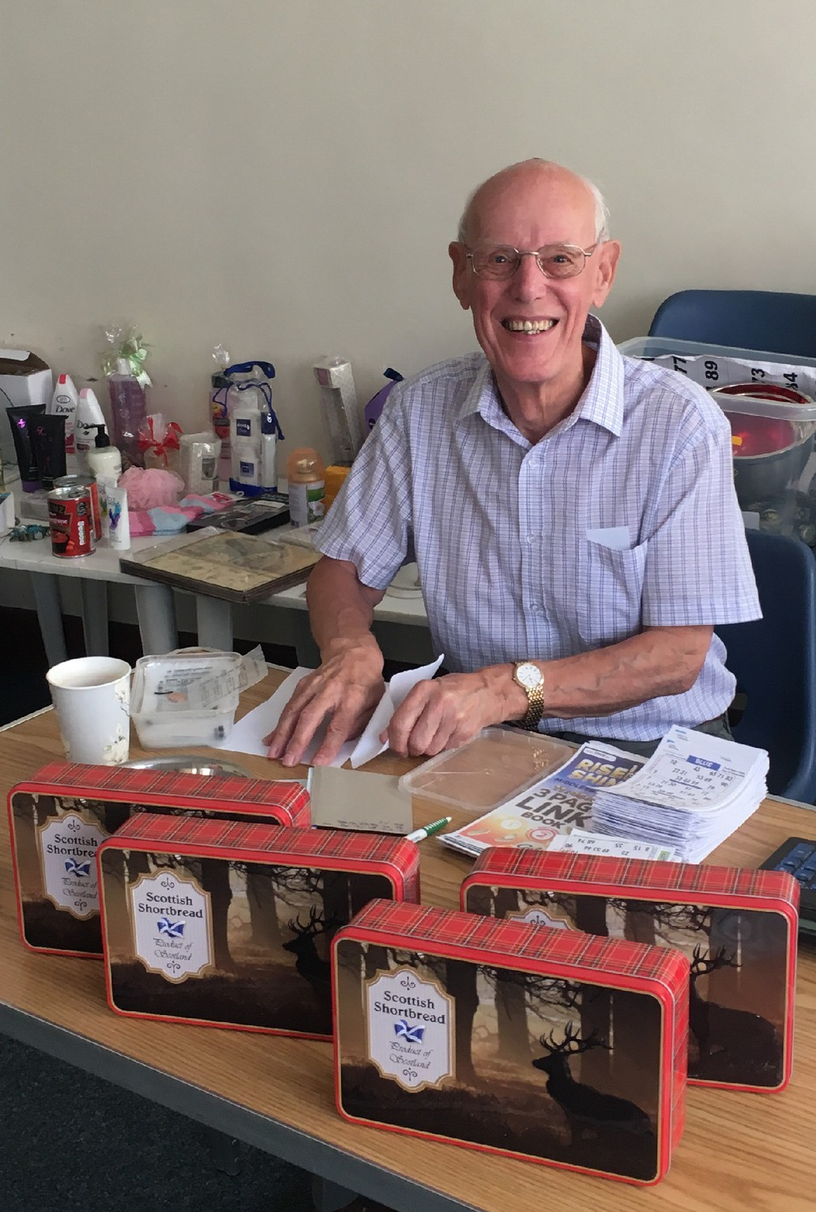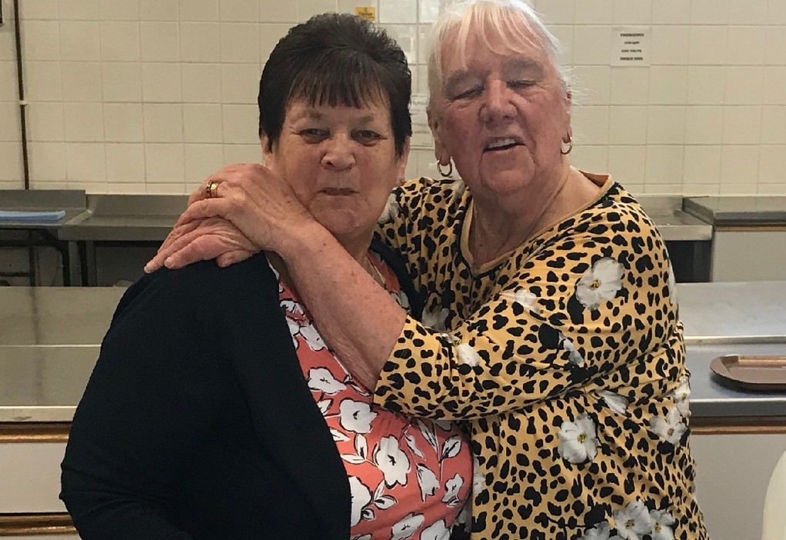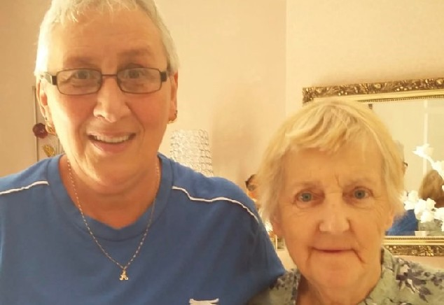

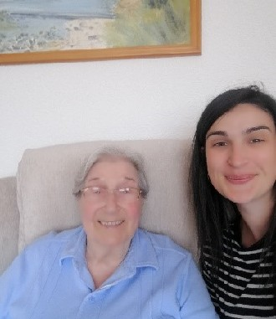 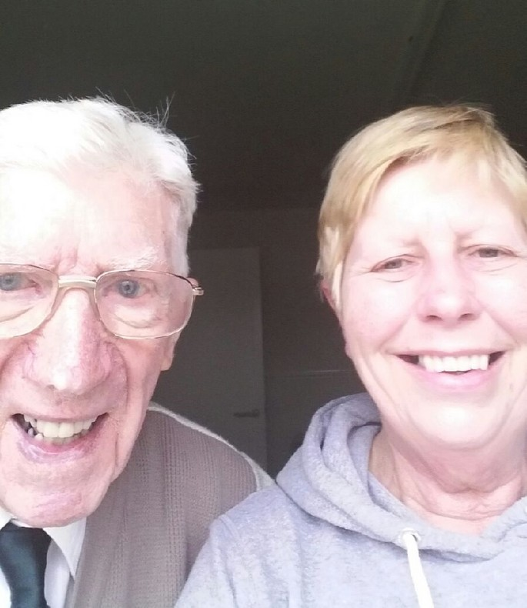 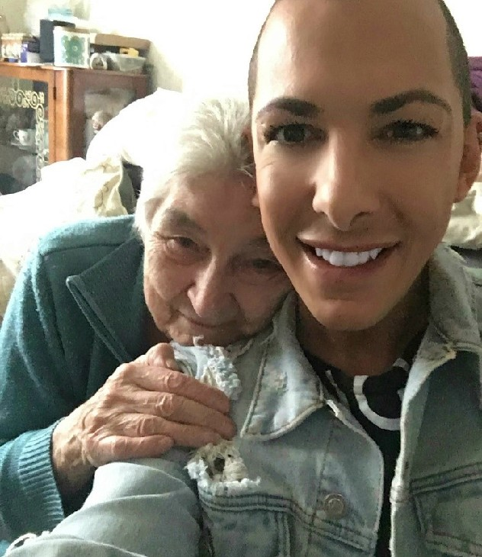

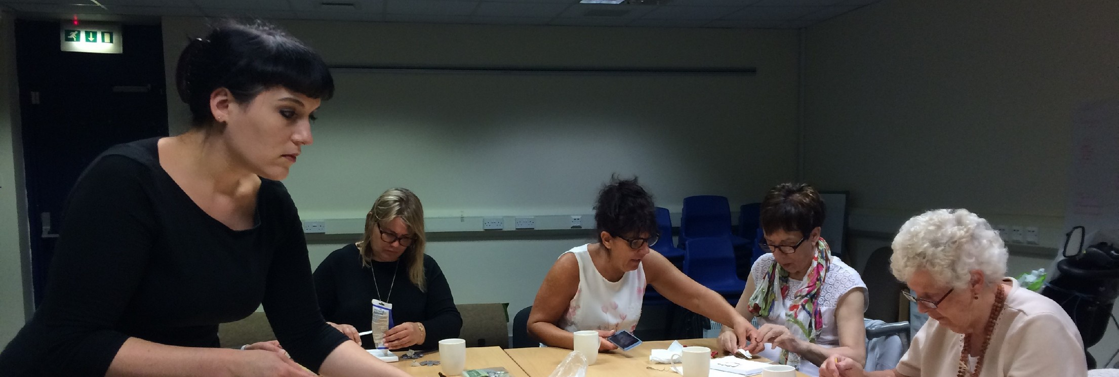



with Age UK Teesside

Age UK Teesside is a registered charity (702714) and company limited by guarantee. Registered in England and Wales number 2152353. Registered Office, Dorothy Rose Suites, The TAD Centre, Ormesby Road, Middlesbrough, TS3 7SF.