**Would you like to get involved with the work the National Trust does?**

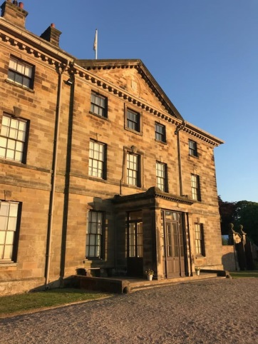**Do you love visiting Ormesby Hall?**

**Then why not become a volunteer?**

***What’s it like to be a volunteer at Ormesby Hall?***

* You get to work in a friendly team of people with volunteers from all walks of life
* It’s great working in the fascinating surrounds of Ormesby Hall
* New interesting information keeps popping up
* You can try new things or just explore your existing interests
* The proud feeling you get when you know you’re helping to look after a special place and bring it to life

***What volunteering roles/opportunities are there at Ormesby Hall?***

* Room Guide
* Tea Room
* Conservation
* Education
* Events
* Gardening
* Model Railways
* Welcome Team
* Second-hand Books
* Raffle Ticket Sales
* Ranger

***Am I able to volunteer in more than one area?***

Of course. Just because you start the volunteering journey in one area doesn’t mean you can’t branch out. Being a Room Guide doesn’t mean you can’t help out in the gardens from time to time.

***What are the benefits of becoming a volunteer?***

* 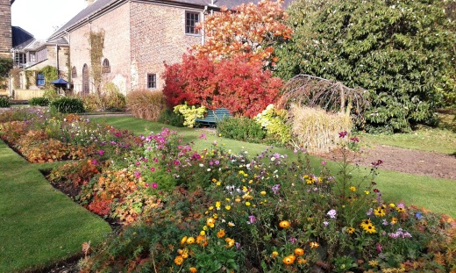Meeting a wide variety of people and making new

friends

* Helping visitors have a great day out
* Chance to learn new skills and the flexibility to help

out in other areas

* Rewards and recognition for long service
* Social events such as volunteer outings, summer

BBQ and thank you meals

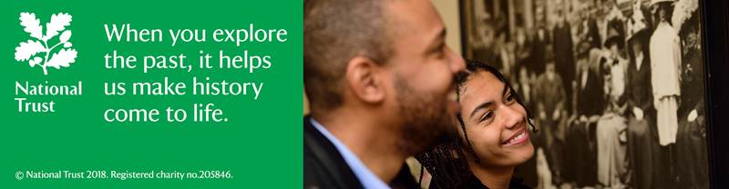

***Are there age restrictions to becoming a volunteer?***

* There is no minimum or maximum age as long as you can make a useful and safe contribution and the activity is suitable for your age
* ******If you are under 18 your parent/guardian must give permission for you to volunteer and you must be supervised by an adult and not left alone – we cannot always provide supervision so for some roles a parent/guardian may need to also volunteer.

***Will I be able to claim for travel expenses?***

Yes, providing you are travelling a minimum of 5 miles (round trip). Expenses are capped a 40 miles (per round trip). You will be given more information about claiming travel expenses at the volunteer induction when you start.

***Do I have to commit to hours each week?***

* No, but some roles eg Room Guide do benefit from regular involvement. We can work together to decide what works best for everyone
* Opportunities for non-regular involvement during busy times eg school holidays and special events.
* We do ask you to let us know in as much advance as possible as to when you can come and volunteer. This is so we can organise rotas to ensure we have sufficient volunteers in to cover our needs.

***I want to become a volunteer, what do I do next?***

Complete an application form and return to Dawn Harper, Ormesby Hall, Church Lane, Ormesby, Middlesbrough, TS7 9AS or email it to [dawn.harper@nationaltrust.org.uk](mailto:dawn.harper@nationaltrust.org.uk). Alternatively you can telephone Dawn on 01642 328908 to discuss opportunities in more detail. You can also take a look at the Ormesby Hall volunteering page by visiting:-

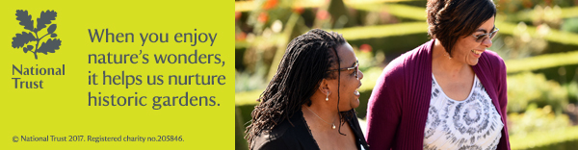[www.nationaltrust.org.uk/ormesby-hall/features/join-the-ormesby-volunteering-team](http://www.nationaltrust.org.uk/ormesby-hall/features/join-the-ormesby-volunteering-team)