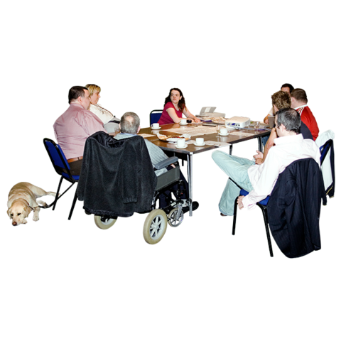

Inclusion North

Autism and Learning Disability Citizenship Boards

Who is Inclusion North:

Inclusion North exists to make inclusion real for all people with a learning disability and autism.

We do this by working with people with a learning disability, autism, family carers and organisations that support them.

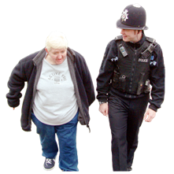  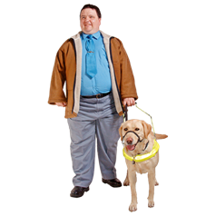  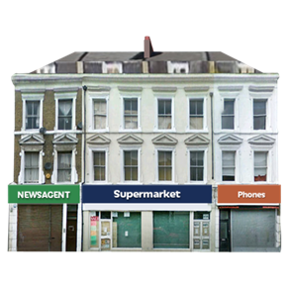 | Our work:  We work to change society so that everybody with a learning disability and autism can live as full, active, and equal citizens.  This means changing the way people think, and the way things are done.
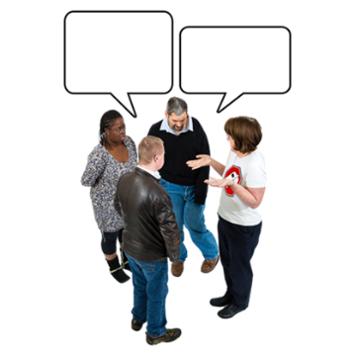 | About the citizenship board:  These roles are for people with lived experience of autism and/or a learning disability.  We will need you to use your lived experience to help others to have a voice and to plan and deliver good services, and to improve the way things are done.
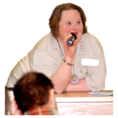 | About being a citizenship board member and the pay you will get:  All members will be paid an involvement fee for each meeting they attend. This is £75 per meeting. There are 4 meetings each year.  You will be part of a bigger team working together across the region.
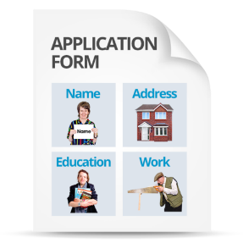 | This form is for you to tell us a bit about why you think you think you will be good for this role.  You can also send us a voice recording or a video film that answers these questions if you prefer.
Please send back your answers to Kimberly Bellhouse
Email: kimberly.bellhouse@inclusionnorth.org
By Friday 22nd March.
Or you can send it in the post to:
Kimberly Bellhouse
Inclusion North
Suite 12a
Unity Business Centre
Roundhay Road
Leeds
LS7 1AB
What is the Inclusion North Expert Adviser Hub?
T

We work to change society so that everybody with a learning disability can live as full, active, and equal citizens.
This means changing the way people think, and the way things are done.
.
The Hub employs people with a learning disability, autism or both and family carers as Expert Advisers.

This section is about you

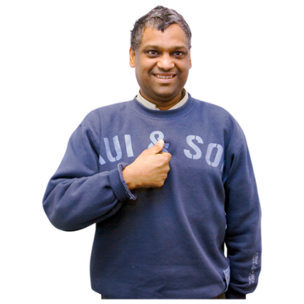
Your name

Your address (please include postcode)

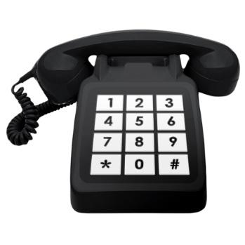
Phone number

Email address

What is the best way to contact you? (please circle)
Phone? E mail? Letter

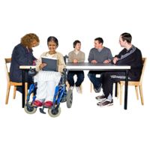 | Are you interested in joining the learning disability or the autism board? please circle one  Learning Disability Citizenship Board  Autism Citizenship Board
Are you an adult aged 18 years or older? Please circle one

Yes, I am an adult

No, I am younger than 18

Are you able to travel to meetings in person (remember we will pay your travel expenses)

Yes, I can travel to meetings

No, I can only come to meetings virtually

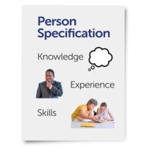  About My |  | About your skills and experiences  Why would you like to do this role?  Why are you the right person for the role?
About My |  | Tell us about your skills and experience or why  you want to do this work.  This could be speaking up in meeting, helping others to speak up, or wanting to learn how to be part of changing things.
Thankyou for filling in the form please send it to Kimberly.

